Chapter 10
Making Capital Investment Decisions

Multiple Choice Questions
1. The difference between a firm's future cash flows if it accepts a project and the firm's future cash flows if it does not accept the project is referred to as the project's:
A. incremental cash flows.
B. internal cash flows.
C. external cash flows.
D. erosion effects.
E. financing cash flows.

2. The fact that a proposed project is analyzed based on the project's incremental cash flows is the assumption behind which one of the following principles?
A. underlying value principle
B. stand-alone principle
C. equivalent cost principle
D. salvage principle
E. fundamental principle

3. Which one of the following costs was incurred in the past and cannot be recouped?
A. incremental
B. side
C. sunk
D. opportunity
E. erosion

4. The option that is foregone so that an asset can be utilized by a specific project is referred to as which one of the following?
A. salvage value
B. wasted value
C. sunk cost
D. opportunity cost
E. erosion

5. Which one of the following best describes the concept of erosion?
A. expenses that have already been incurred and cannot be recovered
B. change in net working capital related to implementing a new project
C. the cash flows of a new project that come at the expense of a firm's existing cash flows
D. the alternative that is forfeited when a fixed asset is utilized by a project
E. the differences in a firm's cash flows with and without a particular project

6. Which one of the following best describes pro forma financial statements?
A. financial statements expressed in a foreign currency
B. financial statements where the assets are expressed as a percentage of total assets and costs are expressed as a percentage of sales
C. financial statements showing projected values for future time periods
D. financial statements expressed in real dollars, given a stated base year
E. financial statements where all accounts are expressed as a percentage of last year's values

7. Which one of the following is the depreciation method which allows accelerated write-offs of property under various lifetime classifications?
A. IRR
B. ACRS
C. AAR
D. straight-line to zero
E. straight-line with salvage

8. The depreciation tax shield is best defined as the:
A. amount of tax that is saved when an asset is purchased.
B. tax that is avoided when an asset is sold as salvage.
C. amount of tax that is due when an asset is sold.
D. amount of tax that is saved because of the depreciation expense.
E. amount by which the aftertax depreciation expense lowers net income.

9. The annual annuity stream of payments that has the same present value as a project's costs is referred to as which one of the following?
A. yearly incremental costs
B. sunk costs
C. opportunity costs
D. erosion cost
E. equivalent annual cost

10. Kelley's Baskets makes handmade baskets for distribution to upscale retail outlets. The firm is currently considering making handmade wreaths as well. Which one of the following is the best example of an incremental operating cash flow related to the wreath project?
A. storing supplies in the same space currently used for materials storage
B. utilizing the basket manager to oversee wreath production
C. hiring additional employees to handle the increased workload should the firm accept the wreath project
D. researching the market to determine if wreath sales might be profitable before deciding to proceed
E. planning on lower interest expense by assuming the proceeds of the wreath sales will be used to reduce the firm's currently outstanding debt

11. Danielle's is a furniture store that is considering adding appliances to its offerings. Which of the following should be considered incremental cash flows of this project?
I. utilizing the credit offered by a supplier to purchase the appliance inventory
II. benefiting from increased furniture sales to appliance customers
III. borrowing money from a bank to fund the appliance project
IV. purchasing parts for inventory to handle any appliance repairs that might be necessary
A. I and II only
B. III and IV only
C. I, II, and IV only
D. II, III, and IV only
E. I, II, III, and IV

12. The stand-alone principle advocates that project analysis should be based solely on which one of the following costs?
A. sunk
B. total
C. variable
D. incremental
E. fixed

13. Which one of the following is an example of a sunk cost?
A. $1,500 of lost sales because an item was out of stock
B. $1,200 paid to repair a machine last year
C. $20,000 project that must be forfeited if another project is accepted
D. $4,500 reduction in current shoe sales if a store commences selling sandals
E. $1,800 increase in comic book sales if a store commences selling puzzles

14. G & L Plastic Molders spent $1,200 last week repairing a machine. This week the company is trying to decide if the machine could be better utilized if they assigned it a proposed project. When analyzing the proposed project, the $1,200 should be treated as which type of cost?
A. opportunity
B. fixed
C. incremental
D. erosion
E. sunk

15. Which one of the following best illustrates erosion as it relates to a hot dog stand located on the beach?
A. providing both ketchup and mustard for its customer's use
B. repairing the roof of the hot dog stand because of water damage
C. selling fewer hot dogs because hamburgers were added to the menu
D. offering French fries but not onion rings
E. losing sales due to bad weather

16. Which of the following should be included in the analysis of a new product?
I. money already spent for research and development of the new product
II. reduction in sales for a current product once the new product is introduced
III. increase in accounts receivable needed to finance sales of the new product
IV. market value of a machine owned by the firm which will be used to produce the new product
A. I and III only
B. II and IV only
C. I, II, and III only
D. II, III, and IV only
E. I, II, III, and IV

17. You are considering the purchase of a new machine. Your analysis includes the evaluation of two machines which have differing initial and ongoing costs and differing lives. Whichever machine is purchased will be replaced at the end of its useful life. You should select the machine which has the:
A. longest life.
B. highest annual operating cost.
C. lowest annual operating cost.
D. highest equivalent annual cost.
E. lowest equivalent annual cost.

18. The bid price is:
A. an aftertax price.
B. the aftertax contribution margin.
C. the highest price you should charge if you want the project.
D. the only price you can bid if the project is to be profitable.
E. the minimum price you should charge if you want to financially breakeven.

19. Which one of the following will increase a bid price?
A. a decrease in the fixed costs
B. a reduction in the net working capital requirement
C. a reduction in the firm's tax rate
D. an increase in the salvage value
E. an increase in the required rate of return

20. All of the following are related to a proposed project. Which of these should be included in the cash flow at time zero?
I. purchase of $1,400 of parts inventory needed to support the project
II. loan of $125,000 used to finance the project
III. depreciation tax shield of $1,100
IV. $6,500 of equipment needed to commence the project
A. I and II only
B. I and IV only
C. II and IV only
D. I, II, and IV only
E. I, II, III, and IV

21. Changes in the net working capital requirements:
A. can affect the cash flows of a project every year of the project's life.
B. only affect the initial cash flows of a project.
C. only affect the cash flow at time zero and the final year of a project.
D. are generally excluded from project analysis due to their irrelevance to the total project.
E. reflect only the changes in the current asset accounts.

22. Which one of the following is a project cash inflow? Ignore any tax effects.
A. decrease in accounts payable
B. increase in inventory
C. decrease in accounts receivable
D. depreciation expense based on MACRS
E. equipment acquisition

23. Net working capital:
A. can be ignored in project analysis because any expenditure is normally recouped at the end of the project.
B. requirements, such as an increase in accounts receivable, create a cash inflow at the beginning of a project.
C. is rarely affected when a new product is introduced.
D. can create either a cash inflow or a cash outflow at time zero of a project.
E. is the only expenditure where at least a partial recovery can be made at the end of a project.

24. The operating cash flow of a cost cutting project:
A. is equal to the depreciation tax shield.
B. is equal to zero because there is no incremental sales.
C. can only be analyzed by projecting the sales and costs for a firm's entire operations.
D. includes any changes that occur in the current accounts.
E. can be positive even though there are no sales.

25. Pro forma statements for a proposed project should:
I. be compiled on a stand-alone basis.
II. include all the incremental cash flows related to the project.
III. generally exclude interest expense.
IV. include all project-related fixed asset acquisitions and disposals.
A. I and II only
B. II and III only
C. I, II, and IV only
D. II, III, and IV only
E. I, II, III, and IV

26. Which one of the following statements is correct?
A. Project analysis should only include the cash flows that affect the income statement.
B. A project can create a positive operating cash flow without affecting sales.
C. The depreciation tax shield creates a cash outflow for a project.
D. Interest expense should always be included as a cash outflow when analyzing a project.
E. The opportunity cost of a company-owned building that is going to be used in a new project should be included as a cash inflow to the project.

27. A company that utilizes the MACRS system of depreciation:
A. will have equal depreciation costs each year of an asset's life.
B. will have a greater tax shield in year two of a project than it would have if the firm had opted for straight-line depreciation, given the same depreciation life.
C. can depreciate the cost of land, if it so desires.
D. will expense less than the entire cost of an asset.
E. cannot expense any of the cost of a new asset during the first year of the asset's life.

28. Morris Motors just purchased some MACRS 5-year property at a cost of $216,000. Which one of the following will correctly give you the book value of this equipment at the end of year 2?
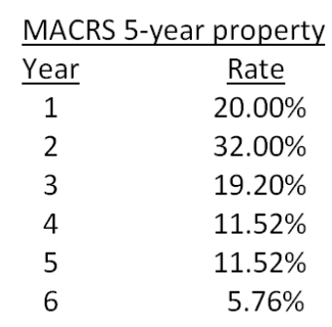
A. $216,000/(1 + 0.20 + 0.32)
B. $216,000  (1 - 0.20 - 0.32)
C. $216,000  (0.20 + 0.32)
D. [$216,000  (1 - 0.20)]  (1 - 0.32)
E. $216,000/[(1 + 0.20)(1 + 0.32)]

29. Keyser Petroleum just purchased some equipment at a cost of $67,000. What is the proper methodology for computing the depreciation expense for year 2 if the equipment is classified as 5-year property for MACRS?
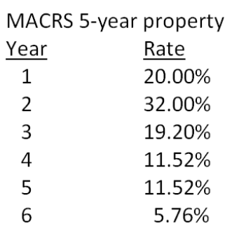
A. $67,000  (1 - 0.20)  0.32
B. $67,000/(1 - 0.20 - 0.32)
C. $67,000  (1 + 0.32)
D. $67,000  (1 - 0.32)
E. $67,000  0.32

30. The current book value of a fixed asset that was purchased two years ago is used in the computation of which one of the following?
A. depreciation tax shield
B. tax due on the salvage value of that asset
C. current year's operating cash flow
D. change in net working capital
E. MACRS depreciation for the current year

31. The net book value of equipment will:
A. remain constant over the life of the equipment.
B. vary in response to changes in the market value.
C. decrease at a constant rate when MACRS depreciation is used.
D. increase over the taxable life of an asset.
E. decrease slower under straight-line depreciation than under MACRS.

32. Three years ago, Knox Glass purchased a machine for a 3-year project. The machine is being depreciated straight-line to zero over a 5-year period. Today, the project ended and the machine was sold. Which one of the following correctly defines the aftertax salvage value of that machine? (T represents the relevant tax rate)
A. Sale price + (Sales price - Book value)  T
B. Sale price + (Sales price - Book value)  (1 - T)
C. Sale price + (Book value - Sale price)  T
D. Sale price + (Book value - Sale price)  (1 - T)
E. Sale price  (1 - T)

33. Which one of the following is a correct method for computing the operating cash flow of a project assuming that the interest expense is equal to zero?
A. EBIT + D
B. EBIT - T
C. NI + D
D. (Sales - Costs)  (1 - D)  (1- T)
E. (Sales - Costs)  (1 - T)

34. The operating cash flow for a project should exclude which one of the following?
A. taxes
B. variable costs
C. fixed costs
D. interest expense
E. depreciation tax shield

35. The bottom-up approach to computing the operating cash flow applies only when:
A. both the depreciation expense and the interest expense are equal to zero.
B. the interest expense is equal to zero.
C. the project is a cost-cutting project.
D. no fixed assets are required for a project.
E. both taxes and the interest expense are equal to zero.

36. The top-down approach to computing the operating cash flow:
A. ignores noncash expenses.
B. applies only if a project increases sales.
C. applies only to cost cutting projects.
D. is equal to sales - costs - taxes + depreciation.
E. is used solely to compute a bid price.

37. Increasing which one of the following will increase the operating cash flow assuming that the bottom-up approach is used to compute the operating cash flow?
A. erosion effects
B. taxes
C. fixed expenses
D. salaries
E. depreciation expense

38. Which one of the following statements is correct concerning bid prices?
A. The bid price is the maximum price that a firm should bid.
B. A firm can submit a bid that is higher than the computed bid price and still break even.
C. A bid price ignores taxes.
D. A bid price should be computed based solely on the operating cash flows of the project.
E. A bid price should be computed based on a zero percent required rate of return.

39. Dan is comparing three machines to determine which one to purchase. The machines sell for differing prices, have differing operating costs, differing machine lives, and will be replaced when worn out. Which one of the following computational methods should Dan use as the basis for his decision?
A. internal rate of return
B. operating cash flow
C. equivalent annual cost
D. depreciation tax shield
E. bottom-up operating cash flow

40. The equivalent annual cost method is useful in determining:
A. which one of two machines to purchase if the machines are mutually exclusive, have differing lives, and are a one-time purchase.
B. the tax shield benefits of depreciation given the purchase of new assets for a project.
C. the operating cash flows of a cost-cutting project.
D. which one of two investments to accept when the investments have different required rates of return.
E. which one of two machines should be purchased when the machines are mutually exclusive, have different machine lives, and will be replaced once they are worn out.

41. When using the equivalent annual cost as a basis for deciding which equipment should be purchased, the equipment under consideration must fit which two of the following criteria?
I. differing productive lives
II. differing manufacturers
III. required replacement at end of economic life
IV. differing initial cost
A. I and II
B. I and III
C. I and IV
D. II and IIII
E. II and IV

42. The equivalent annual cost considers which of the following?
I. required rate of return
II. operating costs
III. need for replacement
IV. aftertax salvage value
A. I and II only
B. II and IV only
C. II, III, and IV only
D. I, II, and IV only
E. I, II, III, and IV

43. The bid price always assumes which one of the following?
A. A project has a one-year life.
B. The aftertax net income of the project is zero.
C. The net present value of the project is zero.
D. Any assets purchased will have a positive salvage value at the end of the project.
E. Assets will be depreciated based on MACRS.

44. Which one of the following would make a project unacceptable?
A. cash inflow for net working capital at time zero
B. requiring fixed assets that would have no salvage value
C. an equivalent annual cost that exceeds that of an alternative project
D. lack of revenue generation
E. a depreciation tax shield that exceeds the value of the interest expense

45. Decreasing which one of the following will increase the acceptability of a project?
A. sunk costs
B. salvage value
C. depreciation tax shield
D. equivalent annual cost
E. accounts payable requirement

46. Dexter Smith & Co. is replacing a machine simply because it has worn out. The new machine will not affect either sales or operating costs and will not have any salvage value at the end of its 5-year life. The firm has a 34 percent tax rate, uses straight-line depreciation over an asset's life, and has a positive net income. Given this, which one of the following statements is correct?
A. As a project, the new machine has a net present value equal to minus one times the machine's purchase price.
B. The new machine will have a zero rate of return.
C. The new machine will generate positive operating cash flows, at least in the first few years of its life.
D. The new machine will create a cash outflow when the firm disposes of it at the end of its life.
E. The new machine creates erosion effects.

47. Kelly's Corner Bakery purchased a lot in Oil City 6 years ago at a cost of $280,000. Today, that lot has a market value of $340,000. At the time of the purchase, the company spent $15,000 to level the lot and another $20,000 to install storm drains. The company now wants to build a new facility on that site. The building cost is estimated at $1.47 million. What amount should be used as the initial cash flow for this project?
A. -$1,470,000
B. -$1,810,000
C. -$1,825,000
D. -$1,845,000
E. -$1,860,000

48. Sailcloth & More currently produces boat sails and is considering expanding its operations to include awnings for homes and travel trailers. The company owns land beside its current manufacturing facility that could be used for the expansion. The company bought this land 5 years ago at a cost of $319,000. At the time of purchase, the company paid $24,000 to level out the land so it would be suitable for future use. Today, the land is valued at $295,000. The company currently has some unused equipment that it currently owns valued at $38,000. This equipment could be used for producing awnings if $12,000 is spent for equipment modifications. Other equipment costing $490,000 will also be required. What is the amount of the initial cash flow for this expansion project?
A. -$785,000
B. -$823,000
C. -$835,000
D. -$859,000
E. -$883,000

49. Webster & Moore paid $139,000, in cash, for a piece of equipment 3 years ago. At the beginning of last year, the company spent $21,000 to update the equipment with the latest technology. The company no longer uses this equipment in its current operations and has received an offer of $89,000 from a firm that would like to purchase it. Webster & Moore is debating whether to sell the equipment or to expand its operations so that the equipment can be used. When evaluating the expansion option, what value, if any, should the firm assign to this equipment as an initial cost of the project?
A. $0
B. $21,000
C. $89,000
D. $110,000
E. $160,000

50. The Fluffy Feather sells customized handbags. Currently, it sells 18,000 handbags annually at an average price of $89 each. It is considering adding a lower-priced line of handbags that sell for $59 each. The firm estimates it can sell 7,000 of the lower-priced handbags but will sell 3,000 less of the higher-priced handbags by doing so. What is the amount of the sales that should be used when evaluating the addition of the lower-priced handbags?
A. $146,000
B. $275,000
C. $413,000
D. $623,000
E. $680,000

51. Mason Farms purchased a building for $729,000 eight years ago. Six years ago, repairs were made to the building which cost $136,000. The annual taxes on the property are $11,000. The building has a current market value of $825,000 and a current book value of $494,000. The building is totally paid for and solely owned by the firm. If the company decides to use this building for a new project, what value, if any, should be included in the initial cash flow of the project for this building?
A. $494,000
B. $582,000
C. $825,000
D. $865,000
E. $953,000

52. You own a house that you rent for $1,100 a month. The maintenance expenses on the house average $200 a month. The house cost $219,000 when you purchased it 4 years ago. A recent appraisal on the house valued it at $239,000. If you sell the house you will incur $14,000 in real estate fees. The annual property taxes are $4,000. You are deciding whether to sell the house or convert it for your own use as a professional office. What value should you place on this house when analyzing the option of using it as a professional office?
A. $211,800
B. $221,000
C. $225,000
D. $235,000
E. $239,000

53. Nelson Mfg. owns a manufacturing facility that is currently sitting idle. The facility is located on a piece of land that originally cost $159,000. The facility itself cost $1,460,000 to build. As of now, the book value of the land and the facility are $159,000 and $458,000, respectively. The firm owes no debt on either the land or the facility at the present time. The firm received a bid of $1,500,000 for the land and facility last week. The firm's management rejected this bid even though they were told that it is a reasonable offer in today's market. If the firm was to consider using this land and facility in a new project, what cost, if any, should it include in the project analysis?
A. $0
B. $617,000
C. $1,460,000
D. $1,500,000
E. $1,619,000

54. Cool Comfort currently sells 300 Class A spas, 450 Class C spas, and 200 deluxe model spas each year. The firm is considering adding a mid-class spa and expects that if it does it can sell 375 of them. However, if the new spa is added, Class A sales are expected to decline to 225 units while the Class C sales are expected to decline to 200. The sales of the deluxe model will not be affected. Class A spas sell for an average of $12,000 each. Class C spas are priced at $6,000 and the deluxe model sells for $17,000 each. The new mid-range spa will sell for $8,000. What is the value of the erosion?
A. $600,000
B. $1,200,000
C. $1,800,000
D. $2,400,000
E. $3,900,000

55. Jefferson & Sons is evaluating a project that will increase annual sales by $138,000 and annual costs by $94,000. The project will initially require $110,000 in fixed assets that will be depreciated straight-line to a zero book value over the 4-year life of the project. The applicable tax rate is 32 percent. What is the operating cash flow for this project?
A. $11,220
B. $29,920
C. $38,720
D. $46,480
E. $46,620

56. Marie's Fashions is considering a project that will require $28,000 in net working capital and $87,000 in fixed assets. The project is expected to produce annual sales of $75,000 with associated costs of $57,000. The project has a 5-year life. The company uses straight-line depreciation to a zero book value over the life of the project. The tax rate is 30 percent. What is the operating cash flow for this project?
A. -$1,520
B. -$580
C. $420
D. $15,680
E. $17,820

57. The Beach House has sales of $784,000 and a profit margin of 11 percent. The annual depreciation expense is $14,000. What is the amount of the operating cash flow if the company has no long-term debt?
A. $68,760
B. $72,240
C. $86,240
D. $100,240
E. $101,760

58. The Pancake House has sales of $1,642,000, depreciation of $27,000, and net working capital of $218,000. The firm has a tax rate of 35 percent and a profit margin of 6 percent. The firm has no interest expense. What is the amount of the operating cash flow?
A. $98,520
B. $125,520
C. $147,480
D. $268,480
E. $343,520

59. Northern Railway is considering a project which will produce annual sales of $975,000 and increase cash expenses by $859,000. If the project is implemented, taxes will increase from $141,000 to $154,000 and depreciation will increase from $194,000 to $272,000. The company is debt-free. What is the amount of the operating cash flow using the top-down approach?
A. $25,000
B. $103,000
C. $157,000
D. $181,000
E. $209,000

60. Bi-Lo Traders is considering a project that will produce sales of $28,000 and increase cash expenses by $17,500. If the project is implemented, taxes will increase by $3,000. The additional depreciation expense will be $1,600. An initial cash outlay of $1,400 is required for net working capital. What is the amount of the operating cash flow using the top-down approach?
A. $4,500
B. $5,900
C. $6,100
D. $7,500
E. $8,900

61. A proposed expansion project is expected to increase sales of JL Ticker's Store by $35,000 and increase cash expenses by $21,000. The project will cost $24,000 and be depreciated using straight-line depreciation to a zero book value over the 4-year life of the project. The store has a marginal tax rate of 30 percent. What is the operating cash flow of the project using the tax shield approach?
A. $5,600
B. $7,800
C. $11,600
D. $13,300
E. $14,600

62. The Lumber Yard is considering adding a new product line that is expected to increase annual sales by $238,000 and cash expenses by $184,000. The initial investment will require $96,000 in fixed assets that will be depreciated using the straight-line method to a zero book value over the 6-year life of the project. The company has a marginal tax rate of 32 percent. What is the annual value of the depreciation tax shield?
A. $5,120
B. $13,160
C. $25,840
D. $32,560
E. $41,840

63. Bernie's Beverages purchased some fixed assets classified as 5-year property for MACRS. The assets cost $87,000. What will the accumulated depreciation be at the end of year three?
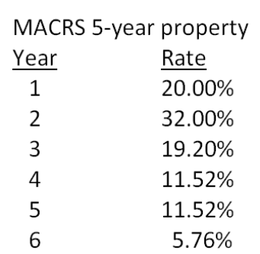
A. $13,520
B. $25,056
C. $38,241
D. $48,759
E. $61,944

64. You just purchased some equipment that is classified as 5-year property for MACRS. The equipment cost $147,000. What will the book value of this equipment be at the end of 4 years should you decide to resell the equipment at that point in time?
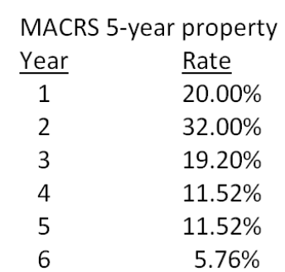
A. $8,467.20
B. $25,401.60
C. $42,336.00
D. $121,598.40
E. $138,532.80

65. Peterborough Trucking just purchased some fixed assets that are classified as 3-year property for MACRS. The assets cost $9,800. What is the amount of the depreciation expense in year 3?
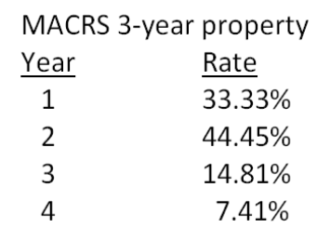
A. $537.52
B. $1,347.17
C. $1,451.38
D. $1,929.11
E. $2,177.56

66. Crafter's Supply purchased some fixed assets 2 years ago at a cost of $38,700. It no longer needs these assets so it is going to sell them today for $25,000. The assets are classified as 5-year property for MACRS. What is the net cash flow from this sale if the firm's tax rate is 30 percent?
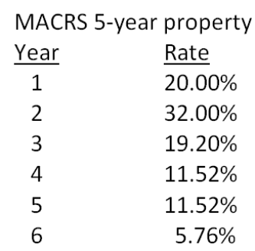
A. $13,122.20
B. $18,576.00
C. $20,843.68
D. $23,072.80
E. $25,211.09

67. You own some equipment that you purchased 4 years ago at a cost of $216,000. The equipment is 5-year property for MACRS. You are considering selling the equipment today for $75,500. Which one of the following statements is correct if your tax rate is 35 percent?
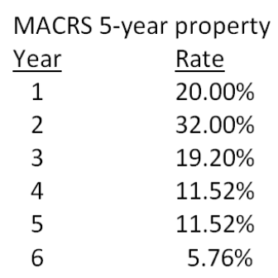
A. The tax due on the sale is $26,425.
B. The book value today is $178,675.20.
C. The accumulated depreciation to date is $37,324.80.
D. The taxable amount on the sale is $37,324.80.
E. The aftertax salvage value is $62,138.68.

68. Edward's Manufactured Homes purchased some machinery 2 years ago for $319,000. These assets are classified as 5-year property for MACRS. The company is replacing this machinery today with newer machines that utilize the latest in technology. The old machines are being sold for $140,000 to a foreign firm for use in its production facility in South America. What is the aftertax salvage value from this sale if the tax rate is 35 percent?
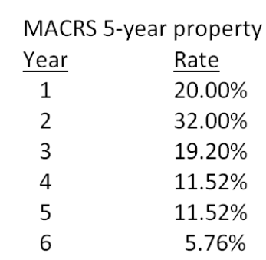
A. $135,408
B. $140,000
C. $142,312
D. $144,592
E. $146,820

69. Bruno's Lunch Counter is expanding and expects operating cash flows of $26,000 a year for 4 years as a result. This expansion requires $39,000 in new fixed assets. These assets will be worthless at the end of the project. In addition, the project requires $3,000 of net working capital throughout the life of the project. What is the net present value of this expansion project at a required rate of return of 16 percent?
A. $18,477.29
B. $21,033.33
C. $28,288.70
D. $29,416.08
E. $32,409.57

70. Jasper Metals is considering installing a new molding machine which is expected to produce operating cash flows of $73,000 a year for 7 years. At the beginning of the project, inventory will decrease by $16,000, accounts receivables will increase by $21,000, and accounts payable will increase by $15,000. All net working capital will be recovered at the end of the project. The initial cost of the molding machine is $249,000. The equipment will be depreciated straight-line to a zero book value over the life of the project. The equipment will be salvaged at the end of the project creating a $48,000 aftertax cash flow. At the end of the project, net working capital will return to its normal level. What is the net present value of this project given a required return of 14.5 percent?
A. $77,211.20
B. $79,418.80
C. $82,336.01
D. $84,049.74
E. $87,925.54

71. A project will produce an operating cash flow of $14,600 a year for 8 years. The initial fixed asset investment in the project will be $48,900. The net aftertax salvage value is estimated at $11,000 and will be received during the last year of the project's life. What is the net present value of the project if the required rate of return is 12 percent?
A. $23,627.54
B. $28,070.26
C. $34,627.54
D. $39,070.26
E. $41,040.83

72. Kwik ‘n Hot Dogs is considering the installation of a new computerized pressure cooker that will cut annual operating costs by $23,000. The system will cost $39,900 to purchase and install. This system is expected to have a 4-year life and will be depreciated to zero using straight-line depreciation. What is the amount of the earnings before interest and taxes for this project?
A. $10,525
B. $13,025
C. $15,525
D. $16,900
E. $19,400

73. Colors and More is considering replacing the equipment it uses to produce crayons. The equipment would cost $1.37 million, have a 12-year life, and lower manufacturing costs by an estimated $304,000 a year. The equipment will be depreciated using straight-line depreciation to a book value of zero. The required rate of return is 15 percent and the tax rate is 35 percent. What is the net income from this proposed project?
A. $18,508.75
B. $40,211.24
C. $66,441.67
D. $123,391.67
E. $136,709.48

74. Gateway Communications is considering a project with an initial fixed asset cost of $2.46 million which will be depreciated straight-line to a zero book value over the 10-year life of the project. At the end of the project the equipment will be sold for an estimated $300,000. The project will not directly produce any sales but will reduce operating costs by $725,000 a year. The tax rate is 35 percent. The project will require $45,000 of inventory which will be recouped when the project ends. Should this project be implemented if the firm requires a 14 percent rate of return? Why or why not?
A. No; The NPV is -$172,937.49.
B. No; The NPV is -$87,820.48.
C. Yes; The NPV is $251,860.34
D. Yes; The NPV is $387,516.67
E. Yes; The NPV is $466,940.57

75. You are working on a bid to build two city parks a year for the next three years. This project requires the purchase of $180,000 of equipment that will be depreciated using straight-line depreciation to a zero book value over the 3-year project life. The equipment can be sold at the end of the project for $34,000. You will also need $20,000 in net working capital for the duration of the project. The fixed costs will be $16,000 a year and the variable costs will be $168,000 per park. Your required rate of return is 15 percent and your tax rate is 34 percent. What is the minimal amount you should bid per park? (Round your answer to the nearest $100)
A. $72,500
B. $128,600
C. $154,300
D. $189,100
E. $217,600

76. You are working on a bid to build two apartment buildings a year for the next 5 years for a local college. This project requires the purchase of $750,000 of equipment that will be depreciated using straight-line depreciation to a zero book value over the project's life. The equipment can be sold at the end of the project for $325,000. You will also need $140,000 in net working capital over the life of the project. The fixed costs will be $628,000 a year and the variable costs will be $1,298,000 per building. Your required rate of return is 14.5 percent for this project and your tax rate is 35 percent. What is the minimal amount, rounded to the nearest $100, you should bid per building?
A. $1,423,700
B. $1,489,500
C. $1,733,000
D. $2,780,600
E. $3,465,900

77. Automated Manufacturers uses high-tech equipment to produce specialized aluminum products for its customers. Each one of these machines costs $1,480,000 to purchase plus an additional $49,000 a year to operate. The machines have a 6-year life after which they are worthless. What is the equivalent annual cost of one these machines if the required return is 16 percent?
A. -$450,657
B. -$427,109
C. -$301,586
D. -$295,667
E. -$256,947

78. Champion Bakers uses specialized ovens to bake its bread. One oven costs $689,000 and lasts about 4 years before it needs to be replaced. The annual operating cost per over is $41,000. What is the equivalent annual cost of an oven if the required rate of return is 13 percent?
A. -$272,638
B. -$248,313
C. -$232,407
D. -$200,561
E. $196,210

79. Precision Tool is analyzing two machines to determine which one it should purchase. The company requires a 15 percent rate of return and uses straight-line depreciation to a zero book value over the life of its equipment. Machine A has a cost of $892,000, annual operating costs of $26,300, and a 4-year life. Machine B costs $1,127,000, has annual operating costs of $19,500, and has a 5-year life. Whichever machine is purchased will be replaced at the end of its useful life. Precision Tool should purchase Machine _____ because it lowers the firm's annual cost by approximately _______ as compared to the other machine.
A. A; $16,965.
B. A; $17,404
C. B; $16,965
D. B; $17,404
E. B; $17,521

80. The Buck Store is considering a project that will require additional inventory of $216,000 and will increase accounts payable by $181,000. Accounts receivable are currently $525,000 and are expected to increase by 9 percent if this project is accepted. What is the project's initial cash flow for net working capital?
A. -$82,250
B. -$12,250
C. $12,250
D. $36,250
E. $44,250

81. The Card Shoppe needs to maintain 23 percent of its sales in net working capital. Currently, the shoppe is considering a 6-year project that will increase sales from its current level of $387,000 to $421,000 the first year and to $465,000 a year for the following 5 years of the project. What amount should be included in the project analysis for net working capital in year 6 of the project?
A. -$17,940
B. -$2,990
C. $0
D. $2,990
E. $17,940

82. Home Furnishings Express is expanding its product offerings to reach a wider range of customers. The expansion project includes increasing the floor inventory by $430,000 and increasing its debt to suppliers by 70 percent of that amount. The company will also spend $450,000 for a building contractor to expand the size of its showroom. As part of the expansion plan, the company will be offering credit to its customers and thus expects accounts receivable to rise by $90,000. For the project analysis, what amount should be used as the initial cash flow for net working capital?
A. -$39,000
B. -$70,000
C. -$156,000
D. -$219,000
E. -$391,000

83. Hollister & Hollister is considering a new project. The project will require $522,000 for new fixed assets, $218,000 for additional inventory, and $39,000 for additional accounts receivable. Short-term debt is expected to increase by $165,000. The project has a 6-year life. The fixed assets will be depreciated straight-line to a zero book value over the life of the project. At the end of the project, the fixed assets can be sold for 20 percent of their original cost. The net working capital returns to its original level at the end of the project. The project is expected to generate annual sales of $875,000 with costs of $640,000. The tax rate is 34 percent and the required rate of return is 14 percent. What is the project's cash flow at time zero?
A. -$536,000
B. -$614,000
C. -$720,000
D. -$779,000
E. -$944,000

84. Hollister & Hollister is considering a new project. The project will require $522,000 for new fixed assets, $218,000 for additional inventory, and $39,000 for additional accounts receivable. Short-term debt is expected to increase by $165,000. The project has a 6-year life. The fixed assets will be depreciated straight-line to a zero book value over the life of the project. At the end of the project, the fixed assets can be sold for 20 percent of their original cost. The net working capital returns to its original level at the end of the project. The project is expected to generate annual sales of $875,000 and costs of $640,000. The tax rate is 34 percent and the required rate of return is 14 percent. What is the amount of the earnings before interest and taxes for the first year of this project?
A. $97,680
B. $130,000
C. $148,000
D. $217,320
E. $235,000

85. Hollister & Hollister is considering a new project. The project will require $522,000 for new fixed assets, $218,000 for additional inventory, and $39,000 for additional accounts receivable. Short-term debt is expected to increase by $165,000. The project has a 6-year life. The fixed assets will be depreciated straight-line to a zero book value over the life of the project. At the end of the project, the fixed assets can be sold for 20 percent of their original cost. The net working capital returns to its original level at the end of the project. The project is expected to generate annual sales of $875,000 and costs of $640,000. The tax rate is 34 percent and the required rate of return is 14 percent. What is the amount of the aftertax cash flow from the sale of the fixed assets at the end of this project?
A. $35,496
B. $68,904
C. $104,400
D. $287,615
E. $344,520

86. Hollister & Hollister is considering a new project. The project will require $522,000 for new fixed assets, $218,000 for additional inventory, and $39,000 for additional accounts receivable. Short-term debt is expected to increase by $165,000. The project has a 6-year life. The fixed assets will be depreciated straight-line to a zero book value over the life of the project. At the end of the project, the fixed assets can be sold for 20 percent of their original cost. The net working capital returns to its original level at the end of the project. The project is expected to generate annual sales of $875,000 and costs of $640,000. The tax rate is 34 percent and the required rate of return is 14 percent. What is the cash flow recovery from net working capital at the end of this project?
A. $14,000
B. $75,000
C. $92,000
D. $344,000
E. $422,000

87. Keyser Mining is considering a project that will require the purchase of $980,000 in new equipment. The equipment will be depreciated straight-line to a zero book value over the 7-year life of the project. The equipment can be scraped at the end of the project for 5 percent of its original cost. Annual sales from this project are estimated at $420,000. Net working capital equal to 20 percent of sales will be required to support the project. All of the net working capital will be recouped. The required return is 16 percent and the tax rate is 35 percent. What is the value of the depreciation tax shield in year 4 of the project?
A. $49,000
B. $52,200
C. $68,600
D. $71,400
E. $76,500

88. Keyser Mining is considering a project that will require the purchase of $980,000 in new equipment. The equipment will be depreciated straight-line to a zero book value over the 7-year life of the project. The equipment can be scraped at the end of the project for 5 percent of its original cost. Annual sales from this project are estimated at $420,000. Net working capital equal to 20 percent of sales will be required to support the project. All of the net working capital will be recouped. The required return is 16 percent and the tax rate is 35 percent. What is the amount of the aftertax salvage value of the equipment?
A. $17,150
B. $31,850
C. $118,800
D. $237,600
E. $343,000

89. Keyser Mining is considering a project that will require the purchase of $980,000 in new equipment. The equipment will be depreciated straight-line to a zero book value over the 7-year life of the project. The equipment can be scraped at the end of the project for 5 percent of its original cost. Annual sales from this project are estimated at $420,000. Net working capital equal to 20 percent of sales will be required to support the project. All of the net working capital will be recouped. The required return is 16 percent and the tax rate is 35 percent. What is the recovery amount attributable to net working capital at the end of the project?
A. $21,000
B. $54,600
C. $84,000
D. $178,000
E. $196,000

Essay Questions
90. In a single sentence, explain how you can determine which cash flows should be included in the analysis of a project.

91. What is the formula for the tax-shield approach to OCF? Explain the two key points the formula illustrates.

92. What is the primary purpose of computing the equivalent annual costs when comparing two machines? What is the assumption that is being made about each machine?

93. Assume a firm sets its bid price for a project at the minimum level as computed using the discounted cash flow method. Given this, what do you know about the net present value and the internal rate of return on the project as bid?

94. Can the initial cash flow at time zero for a project ever be a positive value? If yes, give an example. If no, explain why not.

95. How can two firms arrive at two different bid prices when bidding for the same job and given the same bid specifications?

Multiple Choice Questions
96. Winnebagel Corp. currently sells 28,200 motor homes per year at $42,300 each, and 11,280 luxury motor coaches per year at $79,900 each. The company wants to introduce a new portable camper to fill out its product line. It hopes to sell 19,740 of these campers per year at $11,280 each. An independent consultant has determined that if Winnebagel introduces the new campers, it should boost the sales of its existing motor homes by 4,700 units per year, and reduce the sales of its motor coaches by 1,222 units per year. What is the amount that should be used as the annual sales figure when evaluating this project?
A. $297,613,400
B. $301,002,300
C. $314,141,800
D. $323,839,400
E. $327,289,500

97. Consider the following income statement:
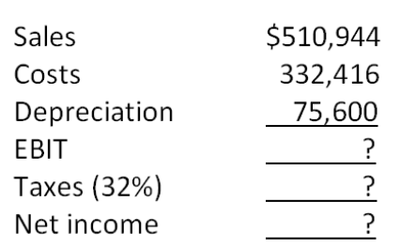
What is the amount of the depreciation tax shield?
A. $23,607
B. $24,192
C. $24,598
D. $26,211
E. $26,919

98. Consider an asset that costs $176,000 and is depreciated straight-line to zero over its 11-year tax life. The asset is to be used in a 7-year project; at the end of the project, the asset can be sold for $22,000. The relevant tax rate is 30 percent. What is the aftertax cash flow from the sale of this asset?
A. $31,800
B. $32,600
C. $33,300
D. $34,100
E. $34,600

99. Phone Home, Inc. is considering a new 6-year expansion project that requires an initial fixed asset investment of $5.994 million. The fixed asset will be depreciated straight-line to zero over its 6-year tax life, after which time it will be worthless. The project is estimated to generate $5,328,000 in annual sales, with costs of $2,131,200. The tax rate is 31 percent. What is the operating cash flow for this project?
A. $1,894,318
B. $2,211,407
C. $2,515,482
D. $2,663,021
E. $2,848,315

100. Phone Home, Inc. is considering a new 5-year expansion project that requires an initial fixed asset investment of $2.484 million. The fixed asset will be depreciated straight-line to zero over its 5-year tax life, after which time it will be worthless. The project is estimated to generate $2,208,000 in annual sales, with costs of $883,200. The tax rate is 32 percent and the required return on the project is 11 percent. What is the net present value for this project?
A. $1,432,155
B. $1,433,059
C. $1,434,098
D. $1,434,217
E. $1,435,008

101. Phone Home, Inc. is considering a new 4-year expansion project that requires an initial fixed asset investment of $3 million. The fixed asset will be depreciated straight-line to zero over its 4-year tax life, after which time it will have a market value of $231,000. The project requires an initial investment in net working capital of $330,000, all of which will be recovered at the end of the project. The project is estimated to generate $2,640,000 in annual sales, with costs of $1,056,000. The tax rate is 31 percent and the required return for the project is 15 percent. What is the net present value for this project?
A. $714,056
B. $733,970
C. $741,335
D. $742,208
E. $744,595

102. Dog Up! Franks is looking at a new sausage system with an installed cost of $397,800. This cost will be depreciated straight-line to zero over the project's 7-year life, at the end of which the sausage system can be scrapped for $61,200. The sausage system will save the firm $122,400 per year in pretax operating costs, and the system requires an initial investment in net working capital of $28,560. All of the net working capital will be recovered at the end of the project. The tax rate is 33 percent and the discount rate is 9 percent. What is the net present value of this project?
A. -$41,311
B. -$7,820
C. $81,507
D. $98,441
E. $118,821

103. Your firm is contemplating the purchase of a new $1,628,000 computer-based order entry system. The system will be depreciated straight-line to zero over its 5-year life. It will be worth $158,400 at the end of that time. You will save $633,600 before taxes per year in order processing costs and you will be able to reduce working capital by $115,764 (this is a one-time reduction). The net working capital will return to its original level when the project ends. The tax rate is 35 percent. What is the internal rate of return for this project?
A. 11.78 percent
B. 13.49 percent
C. 18.21 percent
D. 21.65 percent
E. 23.58 percent

104. A 4-year project has an initial asset investment of $306,600, and initial net working capital investment of $29,200, and an annual operating cash flow of -$46,720. The fixed asset is fully depreciated over the life of the project and has no salvage value. The net working capital will be recovered when the project ends. The required return is 15 percent. What is the project's equivalent annual cost, or EAC?
A. -$158,491
B. -$152,309
C. -$147,884
D. -$145,509
E. -$142,212

105. Heer Enterprises needs someone to supply it with 225,000 cartons of machine screws per year to support its manufacturing needs over the next 7 years, and you've decided to bid on the contract. It will cost you $1,170,000 to install the equipment necessary to start production; you'll depreciate this cost straight-line to zero over the project's life. You estimate that in 7 years, this equipment can be salvaged for $75,000. Your fixed production costs will be $360,000 per year, and your variable production costs should be $12.75 per carton. You also need an initial investment in net working capital of $112,500, all of which will be recovered when the project ends. Your tax rate is 32 percent and you require a 13 percent return on your investment. What bid price per carton should you submit?
A. $17.04
B. $16.56
C. $15.79
D. $15.03
E. $14.81

106. Chapman Machine Shop is considering a 4-year project to improve its production efficiency. Buying a new machine press for $576,000 is estimated to result in $192,000 in annual pretax cost savings. The press falls in the MACRS 5-year class, and it will have a salvage value at the end of the project of $84,000. The press also requires an initial investment in spare parts inventory of $24,000, along with an additional $3,600 in inventory for each succeeding year of the project. The inventory will return to its original level when the project ends. The shop's tax rate is 35 percent and its discount rate is 11 percent. Should the firm buy and install the machine press? Why or why not?
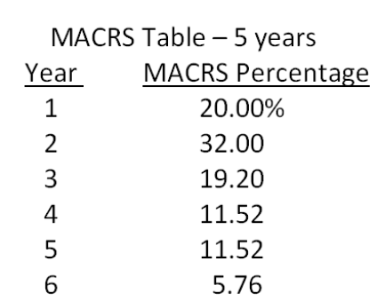
A. no; The net present value is -$7,489.
B. no; The net present value is -$667.
C. yes; The net present value is $211.
D. yes; The net present value is $4,319.
E. yes; The net present value is $8,364.

107. Eads Industrial Systems Company (EISC) is trying to decide between two different conveyor belt systems. System A costs $427,000, has a 6-year life, and requires $112,000 in pretax annual operating costs. System B costs $517,000, has an 8-year life, and requires $79,000 in pretax annual operating costs. Both systems are to be depreciated straight-line to zero over their lives and will have a zero salvage value. Whichever system is chosen, it will not be replaced when it wears out. The tax rate is 33 percent and the discount rate is 24 percent. Which system should the firm choose and why?
A. A; The net present value is $211,516.
B. A; The net present value is -$582,720.
C. A; The net present value is -$314,216.
D. B; The net present value is $308,222.
E. B: The net present value is -$625,123.

108. Consider a project to supply 60,800,000 postage stamps to the U.S. Postal Service for the next 5 years. You have an idle parcel of land available that cost $760,000 five years ago; if the land were sold today, it would net you $912,000, aftertax. The land can be sold for $1,500,000 after taxes in 5 years. You will need to install $2,356,000 in new manufacturing plant and equipment to actually produce the stamps; this plant and equipment will be depreciated straight-line to zero over the project's 5-year life. The equipment can be sold for $456,000 at the end of the project. You will also need $469,000 in initial net working capital for the project, and an additional investment of $38,000 in every year thereafter. All net working capital will be recovered when the project ends. Your production costs are 0.38 cents per stamp, and you have fixed costs of $608,000 per year. Your tax rate is 31 percent and your required return on this project is 11 percent. What bid price per stamp should you submit?
A. $0.018
B. $0.020
C. $0.023
D. $0.026
E. $0.029

Chapter 10 Making Capital Investment Decisions Answer Key

Multiple Choice Questions
1. The difference between a firm's future cash flows if it accepts a project and the firm's future cash flows if it does not accept the project is referred to as the project's:
A. incremental cash flows.
B. internal cash flows.
C. external cash flows.
D. erosion effects.
E. financing cash flows.
Refer to section 10.1

AACSB: N/A
Bloom's: Knowledge
Difficulty: Basic
Learning Objective: 10-1
Section: 10.1
Topic: Incremental cash flows
2. The fact that a proposed project is analyzed based on the project's incremental cash flows is the assumption behind which one of the following principles?
A. underlying value principle
B. stand-alone principle
C. equivalent cost principle
D. salvage principle
E. fundamental principle
Refer to section 10.1

AACSB: N/A
Bloom's: Knowledge
Difficulty: Basic
Learning Objective: 10-1
Section: 10.1
Topic: Stand-along principle
3. Which one of the following costs was incurred in the past and cannot be recouped?
A. incremental
B. side
C. sunk
D. opportunity
E. erosion
Refer to section 10.2

AACSB: N/A
Bloom's: Knowledge
Difficulty: Basic
Learning Objective: 10-1
Section: 10.2
Topic: Sunk cost
4. The option that is foregone so that an asset can be utilized by a specific project is referred to as which one of the following?
A. salvage value
B. wasted value
C. sunk cost
D. opportunity cost
E. erosion
Refer to section 10.2

AACSB: N/A
Bloom's: Knowledge
Difficulty: Basic
Learning Objective: 10-1
Section: 10.2
Topic: Opportunity cost
5. Which one of the following best describes the concept of erosion?
A. expenses that have already been incurred and cannot be recovered
B. change in net working capital related to implementing a new project
C. the cash flows of a new project that come at the expense of a firm's existing cash flows
D. the alternative that is forfeited when a fixed asset is utilized by a project
E. the differences in a firm's cash flows with and without a particular project
Refer to section 10.2

AACSB: N/A
Bloom's: Knowledge
Difficulty: Basic
Learning Objective: 10-1
Section: 10.2
Topic: Erosion
6. Which one of the following best describes pro forma financial statements?
A. financial statements expressed in a foreign currency
B. financial statements where the assets are expressed as a percentage of total assets and costs are expressed as a percentage of sales
C. financial statements showing projected values for future time periods
D. financial statements expressed in real dollars, given a stated base year
E. financial statements where all accounts are expressed as a percentage of last year's values
Refer to section 10.3

AACSB: N/A
Bloom's: Knowledge
Difficulty: Basic
Learning Objective: 10-1
Section: 10.3
Topic: Pro forma financial statements
7. Which one of the following is the depreciation method which allows accelerated write-offs of property under various lifetime classifications?
A. IRR
B. ACRS
C. AAR
D. straight-line to zero
E. straight-line with salvage
Refer to section 10.4

AACSB: N/A
Bloom's: Knowledge
Difficulty: Basic
Learning Objective: 10-1
Section: 10.4
Topic: Accelerated cost recovery system
8. The depreciation tax shield is best defined as the:
A. amount of tax that is saved when an asset is purchased.
B. tax that is avoided when an asset is sold as salvage.
C. amount of tax that is due when an asset is sold.
D. amount of tax that is saved because of the depreciation expense.
E. amount by which the aftertax depreciation expense lowers net income.
Refer to section 10.5

AACSB: N/A
Bloom's: Knowledge
Difficulty: Basic
Learning Objective: 10-1
Section: 10.5
Topic: Depreciation tax shield
9. The annual annuity stream of payments that has the same present value as a project's costs is referred to as which one of the following?
A. yearly incremental costs
B. sunk costs
C. opportunity costs
D. erosion cost
E. equivalent annual cost
Refer to section 10.6

AACSB: N/A
Bloom's: Knowledge
Difficulty: Basic
Learning Objective: 10-4
Section: 10.6
Topic: Equivalent annual cost
10. Kelley's Baskets makes handmade baskets for distribution to upscale retail outlets. The firm is currently considering making handmade wreaths as well. Which one of the following is the best example of an incremental operating cash flow related to the wreath project?
A. storing supplies in the same space currently used for materials storage
B. utilizing the basket manager to oversee wreath production
C. hiring additional employees to handle the increased workload should the firm accept the wreath project
D. researching the market to determine if wreath sales might be profitable before deciding to proceed
E. planning on lower interest expense by assuming the proceeds of the wreath sales will be used to reduce the firm's currently outstanding debt
Refer to section 10.1

AACSB: N/A
Bloom's: Knowledge
Difficulty: Basic
Learning Objective: 10-1
Section: 10.1
Topic: Relevant cash flows
11. Danielle's is a furniture store that is considering adding appliances to its offerings. Which of the following should be considered incremental cash flows of this project?
I. utilizing the credit offered by a supplier to purchase the appliance inventory
II. benefiting from increased furniture sales to appliance customers
III. borrowing money from a bank to fund the appliance project
IV. purchasing parts for inventory to handle any appliance repairs that might be necessary
A. I and II only
B. III and IV only
C. I, II, and IV only
D. II, III, and IV only
E. I, II, III, and IV
Refer to sections 10.1 and 10.2

AACSB: N/A
Bloom's: Comprehension
Difficulty: Basic
Learning Objective: 10-1
Section: 10.1 and 10.2
Topic: Relevant cash flows
12. The stand-alone principle advocates that project analysis should be based solely on which one of the following costs?
A. sunk
B. total
C. variable
D. incremental
E. fixed
Refer to section 10.1

AACSB: N/A
Bloom's: Knowledge
Difficulty: Basic
Learning Objective: 10-1
Section: 10.1
Topic: Incremental costs
13. Which one of the following is an example of a sunk cost?
A. $1,500 of lost sales because an item was out of stock
B. $1,200 paid to repair a machine last year
C. $20,000 project that must be forfeited if another project is accepted
D. $4,500 reduction in current shoe sales if a store commences selling sandals
E. $1,800 increase in comic book sales if a store commences selling puzzles
Refer to section 10.2

AACSB: N/A
Bloom's: Comprehension
Difficulty: Basic
Learning Objective: 10-1
Section: 10.2
Topic: Sunk cost
14. G & L Plastic Molders spent $1,200 last week repairing a machine. This week the company is trying to decide if the machine could be better utilized if they assigned it a proposed project. When analyzing the proposed project, the $1,200 should be treated as which type of cost?
A. opportunity
B. fixed
C. incremental
D. erosion
E. sunk
Refer to section 10.2

AACSB: N/A
Bloom's: Knowledge
Difficulty: Basic
Learning Objective: 10-1
Section: 10.2
Topic: Sunk cost
15. Which one of the following best illustrates erosion as it relates to a hot dog stand located on the beach?
A. providing both ketchup and mustard for its customer's use
B. repairing the roof of the hot dog stand because of water damage
C. selling fewer hot dogs because hamburgers were added to the menu
D. offering French fries but not onion rings
E. losing sales due to bad weather
Refer to section 10.2

AACSB: N/A
Bloom's: Comprehension
Difficulty: Basic
Learning Objective: 10-1
Section: 10.2
Topic: Erosion
16. Which of the following should be included in the analysis of a new product?
I. money already spent for research and development of the new product
II. reduction in sales for a current product once the new product is introduced
III. increase in accounts receivable needed to finance sales of the new product
IV. market value of a machine owned by the firm which will be used to produce the new product
A. I and III only
B. II and IV only
C. I, II, and III only
D. II, III, and IV only
E. I, II, III, and IV
Refer to section 10.2

AACSB: N/A
Bloom's: Comprehension
Difficulty: Basic
Learning Objective: 10-1
Section: 10.2
Topic: Incremental cash flows
17. You are considering the purchase of a new machine. Your analysis includes the evaluation of two machines which have differing initial and ongoing costs and differing lives. Whichever machine is purchased will be replaced at the end of its useful life. You should select the machine which has the:
A. longest life.
B. highest annual operating cost.
C. lowest annual operating cost.
D. highest equivalent annual cost.
E. lowest equivalent annual cost.
Refer to section 10.6

AACSB: N/A
Bloom's: Knowledge
Difficulty: Basic
Learning Objective: 10-4
Section: 10.6
Topic: Equivalent annual cost
18. The bid price is:
A. an aftertax price.
B. the aftertax contribution margin.
C. the highest price you should charge if you want the project.
D. the only price you can bid if the project is to be profitable.
E. the minimum price you should charge if you want to financially breakeven.
Refer to section 10.6

AACSB: N/A
Bloom's: Comprehension
Difficulty: Basic
Learning Objective: 10-3
Section: 10.6
Topic: Bid price
19. Which one of the following will increase a bid price?
A. a decrease in the fixed costs
B. a reduction in the net working capital requirement
C. a reduction in the firm's tax rate
D. an increase in the salvage value
E. an increase in the required rate of return
Refer to section 10.6

AACSB: N/A
Bloom's: Comprehension
Difficulty: Intermediate
Learning Objective: 10-3
Section: 10.6
Topic: Bid price
20. All of the following are related to a proposed project. Which of these should be included in the cash flow at time zero?
I. purchase of $1,400 of parts inventory needed to support the project
II. loan of $125,000 used to finance the project
III. depreciation tax shield of $1,100
IV. $6,500 of equipment needed to commence the project
A. I and II only
B. I and IV only
C. II and IV only
D. I, II, and IV only
E. I, II, III, and IV
Refer to section 10.4

AACSB: N/A
Bloom's: Comprehension
Difficulty: Basic
Learning Objective: 10-1
Section: 10.4
Topic: Project cash flows
21. Changes in the net working capital requirements:
A. can affect the cash flows of a project every year of the project's life.
B. only affect the initial cash flows of a project.
C. only affect the cash flow at time zero and the final year of a project.
D. are generally excluded from project analysis due to their irrelevance to the total project.
E. reflect only the changes in the current asset accounts.
Refer to section 10.4

AACSB: N/A
Bloom's: Comprehension
Difficulty: Basic
Learning Objective: 10-1
Section: 10.4
Topic: Net working capital
22. Which one of the following is a project cash inflow? Ignore any tax effects.
A. decrease in accounts payable
B. increase in inventory
C. decrease in accounts receivable
D. depreciation expense based on MACRS
E. equipment acquisition
Refer to section 10.4

AACSB: N/A
Bloom's: Comprehension
Difficulty: Basic
Learning Objective: 10-1
Section: 10.4
Topic: Project cash flows
23. Net working capital:
A. can be ignored in project analysis because any expenditure is normally recouped at the end of the project.
B. requirements, such as an increase in accounts receivable, create a cash inflow at the beginning of a project.
C. is rarely affected when a new product is introduced.
D. can create either a cash inflow or a cash outflow at time zero of a project.
E. is the only expenditure where at least a partial recovery can be made at the end of a project.
Refer to section 10.4

AACSB: N/A
Bloom's: Comprehension
Difficulty: Basic
Learning Objective: 10-1
Section: 10.4
Topic: Net working capital
24. The operating cash flow of a cost cutting project:
A. is equal to the depreciation tax shield.
B. is equal to zero because there is no incremental sales.
C. can only be analyzed by projecting the sales and costs for a firm's entire operations.
D. includes any changes that occur in the current accounts.
E. can be positive even though there are no sales.
Refer to section 10.6

AACSB: N/A
Bloom's: Comprehension
Difficulty: Basic
Learning Objective: 10-1
Section: 10.6
Topic: Cost reduction project
25. Pro forma statements for a proposed project should:
I. be compiled on a stand-alone basis.
II. include all the incremental cash flows related to the project.
III. generally exclude interest expense.
IV. include all project-related fixed asset acquisitions and disposals.
A. I and II only
B. II and III only
C. I, II, and IV only
D. II, III, and IV only
E. I, II, III, and IV
Refer to section 10.3

AACSB: N/A
Bloom's: Knowledge
Difficulty: Basic
Learning Objective: 10-1
Section: 10.3
Topic: Pro forma statement
26. Which one of the following statements is correct?
A. Project analysis should only include the cash flows that affect the income statement.
B. A project can create a positive operating cash flow without affecting sales.
C. The depreciation tax shield creates a cash outflow for a project.
D. Interest expense should always be included as a cash outflow when analyzing a project.
E. The opportunity cost of a company-owned building that is going to be used in a new project should be included as a cash inflow to the project.
Refer to section 10.6

AACSB: N/A
Bloom's: Comprehension
Difficulty: Basic
Learning Objective: 10-1
Section: 10.6
Topic: Cost cutting project
27. A company that utilizes the MACRS system of depreciation:
A. will have equal depreciation costs each year of an asset's life.
B. will have a greater tax shield in year two of a project than it would have if the firm had opted for straight-line depreciation, given the same depreciation life.
C. can depreciate the cost of land, if it so desires.
D. will expense less than the entire cost of an asset.
E. cannot expense any of the cost of a new asset during the first year of the asset's life.
Refer to section 10.4

AACSB: N/A
Bloom's: Knowledge
Difficulty: Basic
Learning Objective: 10-1
Section: 10.4
Topic: MACRS depreciation
28. Morris Motors just purchased some MACRS 5-year property at a cost of $216,000. Which one of the following will correctly give you the book value of this equipment at the end of year 2?
A. $216,000/(1 + 0.20 + 0.32)
B. $216,000  (1 - 0.20 - 0.32)
C. $216,000  (0.20 + 0.32)
D. [$216,000  (1 - 0.20)]  (1 - 0.32)
E. $216,000/[(1 + 0.20)(1 + 0.32)]
Refer to section 10.4

AACSB: N/A
Bloom's: Knowledge
Difficulty: Basic
Learning Objective: 10-1
Section: 10.4
Topic: MACRS depreciation
29. Keyser Petroleum just purchased some equipment at a cost of $67,000. What is the proper methodology for computing the depreciation expense for year 2 if the equipment is classified as 5-year property for MACRS?
A. $67,000  (1 - 0.20)  0.32
B. $67,000/(1 - 0.20 - 0.32)
C. $67,000  (1 + 0.32)
D. $67,000  (1 - 0.32)
E. $67,000  0.32
Refer to section 10.4

AACSB: N/A
Bloom's: Knowledge
Difficulty: Basic
Learning Objective: 10-1
Section: 10.4
Topic: MACRS depreciation
30. The current book value of a fixed asset that was purchased two years ago is used in the computation of which one of the following?
A. depreciation tax shield
B. tax due on the salvage value of that asset
C. current year's operating cash flow
D. change in net working capital
E. MACRS depreciation for the current year
Refer to section 10.4

AACSB: N/A
Bloom's: Comprehension
Difficulty: Basic
Learning Objective: 10-1
Section: 10.4
Topic: Tax on salvage value
31. The net book value of equipment will:
A. remain constant over the life of the equipment.
B. vary in response to changes in the market value.
C. decrease at a constant rate when MACRS depreciation is used.
D. increase over the taxable life of an asset.
E. decrease slower under straight-line depreciation than under MACRS.
Refer to section 10.4

AACSB: N/A
Bloom's: Comprehension
Difficulty: Basic
Learning Objective: 10-1
Section: 10.4
Topic: Book value
32. Three years ago, Knox Glass purchased a machine for a 3-year project. The machine is being depreciated straight-line to zero over a 5-year period. Today, the project ended and the machine was sold. Which one of the following correctly defines the aftertax salvage value of that machine? (T represents the relevant tax rate)
A. Sale price + (Sales price - Book value)  T
B. Sale price + (Sales price - Book value)  (1 - T)
C. Sale price + (Book value - Sale price)  T
D. Sale price + (Book value - Sale price)  (1 - T)
E. Sale price  (1 - T)
Refer to section 10.4

AACSB: N/A
Bloom's: Knowledge
Difficulty: Basic
Learning Objective: 10-1
Section: 10.4
Topic: Aftertax salvage value
33. Which one of the following is a correct method for computing the operating cash flow of a project assuming that the interest expense is equal to zero?
A. EBIT + D
B. EBIT - T
C. NI + D
D. (Sales - Costs)  (1 - D)  (1- T)
E. (Sales - Costs)  (1 - T)
Refer to section 10.5

AACSB: N/A
Bloom's: Knowledge
Difficulty: Basic
Learning Objective: 10-1
Section: 10.5
Topic: Bottom up operating cash flow
34. The operating cash flow for a project should exclude which one of the following?
A. taxes
B. variable costs
C. fixed costs
D. interest expense
E. depreciation tax shield
Refer to section 10.5

AACSB: N/A
Bloom's: Knowledge
Difficulty: Basic
Learning Objective: 10-1
Section: 10.5
Topic: Operating cash flow
35. The bottom-up approach to computing the operating cash flow applies only when:
A. both the depreciation expense and the interest expense are equal to zero.
B. the interest expense is equal to zero.
C. the project is a cost-cutting project.
D. no fixed assets are required for a project.
E. both taxes and the interest expense are equal to zero.
Refer to section 10.5

AACSB: N/A
Bloom's: Comprehension
Difficulty: Basic
Learning Objective: 10-1
Section: 10.5
Topic: Bottom-up operating cash flow
36. The top-down approach to computing the operating cash flow:
A. ignores noncash expenses.
B. applies only if a project increases sales.
C. applies only to cost cutting projects.
D. is equal to sales - costs - taxes + depreciation.
E. is used solely to compute a bid price.
Refer to section 10.5

AACSB: N/A
Bloom's: Comprehension
Difficulty: Basic
Learning Objective: 10-1
Section: 10.5
Topic: Top-down operating cash flow
37. Increasing which one of the following will increase the operating cash flow assuming that the bottom-up approach is used to compute the operating cash flow?
A. erosion effects
B. taxes
C. fixed expenses
D. salaries
E. depreciation expense
Refer to section 10.5

AACSB: N/A
Bloom's: Comprehension
Difficulty: Basic
Learning Objective: 10-1
Section: 10.5
Topic: Bottom-up operating cash flow
38. Which one of the following statements is correct concerning bid prices?
A. The bid price is the maximum price that a firm should bid.
B. A firm can submit a bid that is higher than the computed bid price and still break even.
C. A bid price ignores taxes.
D. A bid price should be computed based solely on the operating cash flows of the project.
E. A bid price should be computed based on a zero percent required rate of return.
Refer to section 10.6

AACSB: N/A
Bloom's: Comprehension
Difficulty: Basic
Learning Objective: 10-3
Section: 10.6
Topic: Bid price
39. Dan is comparing three machines to determine which one to purchase. The machines sell for differing prices, have differing operating costs, differing machine lives, and will be replaced when worn out. Which one of the following computational methods should Dan use as the basis for his decision?
A. internal rate of return
B. operating cash flow
C. equivalent annual cost
D. depreciation tax shield
E. bottom-up operating cash flow
Refer to section 10.6

AACSB: N/A
Bloom's: Knowledge
Difficulty: Basic
Learning Objective: 10-4
Section: 10.6
Topic: Equivalent annual cost
40. The equivalent annual cost method is useful in determining:
A. which one of two machines to purchase if the machines are mutually exclusive, have differing lives, and are a one-time purchase.
B. the tax shield benefits of depreciation given the purchase of new assets for a project.
C. the operating cash flows of a cost-cutting project.
D. which one of two investments to accept when the investments have different required rates of return.
E. which one of two machines should be purchased when the machines are mutually exclusive, have different machine lives, and will be replaced once they are worn out.
Refer to section 10.6

AACSB: N/A
Bloom's: Knowledge
Difficulty: Basic
Learning Objective: 10-4
Section: 10.6
Topic: Equivalent annual cost
41. When using the equivalent annual cost as a basis for deciding which equipment should be purchased, the equipment under consideration must fit which two of the following criteria?
I. differing productive lives
II. differing manufacturers
III. required replacement at end of economic life
IV. differing initial cost
A. I and II
B. I and III
C. I and IV
D. II and IIII
E. II and IV
Refer to section 10.6

AACSB: N/A
Bloom's: Knowledge
Difficulty: Basic
Learning Objective: 10-4
Section: 10.6
Topic: Equivalent annual cost
42. The equivalent annual cost considers which of the following?
I. required rate of return
II. operating costs
III. need for replacement
IV. aftertax salvage value
A. I and II only
B. II and IV only
C. II, III, and IV only
D. I, II, and IV only
E. I, II, III, and IV
Refer to section 10.6

AACSB: N/A
Bloom's: Knowledge
Difficulty: Basic
Learning Objective: 10-4
Section: 10.6
Topic: Equivalent annual cost
43. The bid price always assumes which one of the following?
A. A project has a one-year life.
B. The aftertax net income of the project is zero.
C. The net present value of the project is zero.
D. Any assets purchased will have a positive salvage value at the end of the project.
E. Assets will be depreciated based on MACRS.
Refer to section 10.6

AACSB: N/A
Bloom's: Comprehension
Difficulty: Basic
Learning Objective: 10-3
Section: 10.6
Topic: Bid price
44. Which one of the following would make a project unacceptable?
A. cash inflow for net working capital at time zero
B. requiring fixed assets that would have no salvage value
C. an equivalent annual cost that exceeds that of an alternative project
D. lack of revenue generation
E. a depreciation tax shield that exceeds the value of the interest expense
Refer to section 10.6

AACSB: N/A
Bloom's: Knowledge
Difficulty: Basic
Learning Objective: 10-4
Section: 10.6
Topic: Equivalent annual cost
45. Decreasing which one of the following will increase the acceptability of a project?
A. sunk costs
B. salvage value
C. depreciation tax shield
D. equivalent annual cost
E. accounts payable requirement
Refer to section 10.6

AACSB: N/A
Bloom's: Knowledge
Difficulty: Basic
Learning Objective: 10-4
Section: 10.6
Topic: Equivalent annual cost
46. Dexter Smith & Co. is replacing a machine simply because it has worn out. The new machine will not affect either sales or operating costs and will not have any salvage value at the end of its 5-year life. The firm has a 34 percent tax rate, uses straight-line depreciation over an asset's life, and has a positive net income. Given this, which one of the following statements is correct?
A. As a project, the new machine has a net present value equal to minus one times the machine's purchase price.
B. The new machine will have a zero rate of return.
C. The new machine will generate positive operating cash flows, at least in the first few years of its life.
D. The new machine will create a cash outflow when the firm disposes of it at the end of its life.
E. The new machine creates erosion effects.
Refer to section 10.5

AACSB: N/A
Bloom's: Comprehension
Difficulty: Basic
Learning Objective: 10-1
Section: 10.5
Topic: Depreciation tax shield
47. Kelly's Corner Bakery purchased a lot in Oil City 6 years ago at a cost of $280,000. Today, that lot has a market value of $340,000. At the time of the purchase, the company spent $15,000 to level the lot and another $20,000 to install storm drains. The company now wants to build a new facility on that site. The building cost is estimated at $1.47 million. What amount should be used as the initial cash flow for this project?
A. -$1,470,000
B. -$1,810,000
C. -$1,825,000
D. -$1,845,000
E. -$1,860,000
CF₀ = -$340,000 - $1,470,000 = -$1,810,000

AACSB: Analytic
Bloom's: Application
Difficulty: Basic
Learning Objective: 10-1
Section: 10.2
Topic: Relevant cash flows
48. Sailcloth & More currently produces boat sails and is considering expanding its operations to include awnings for homes and travel trailers. The company owns land beside its current manufacturing facility that could be used for the expansion. The company bought this land 5 years ago at a cost of $319,000. At the time of purchase, the company paid $24,000 to level out the land so it would be suitable for future use. Today, the land is valued at $295,000. The company currently has some unused equipment that it currently owns valued at $38,000. This equipment could be used for producing awnings if $12,000 is spent for equipment modifications. Other equipment costing $490,000 will also be required. What is the amount of the initial cash flow for this expansion project?
A. -$785,000
B. -$823,000
C. -$835,000
D. -$859,000
E. -$883,000
CF₀ = -$295,000 - $38,000 - $12,000 - $490,000 = -$835,000

AACSB: Analytic
Bloom's: Application
Difficulty: Basic
Learning Objective: 10-1
Section: 10.2
Topic: Relevant costs
49. Webster & Moore paid $139,000, in cash, for a piece of equipment 3 years ago. At the beginning of last year, the company spent $21,000 to update the equipment with the latest technology. The company no longer uses this equipment in its current operations and has received an offer of $89,000 from a firm that would like to purchase it. Webster & Moore is debating whether to sell the equipment or to expand its operations so that the equipment can be used. When evaluating the expansion option, what value, if any, should the firm assign to this equipment as an initial cost of the project?
A. $0
B. $21,000
C. $89,000
D. $110,000
E. $160,000
Relevant value = $89,000

AACSB: Analytic
Bloom's: Application
Difficulty: Basic
Learning Objective: 10-1
Section: 10.2
Topic: Opportunity cost
50. The Fluffy Feather sells customized handbags. Currently, it sells 18,000 handbags annually at an average price of $89 each. It is considering adding a lower-priced line of handbags that sell for $59 each. The firm estimates it can sell 7,000 of the lower-priced handbags but will sell 3,000 less of the higher-priced handbags by doing so. What is the amount of the sales that should be used when evaluating the addition of the lower-priced handbags?
A. $146,000
B. $275,000
C. $413,000
D. $623,000
E. $680,000
Sales = (7,000  $59) + (-3,000  $89) = $146,000

AACSB: Analytic
Bloom's: Application
Difficulty: Basic
Learning Objective: 10-1
Section: 10.2
Topic: Erosion
51. Mason Farms purchased a building for $729,000 eight years ago. Six years ago, repairs were made to the building which cost $136,000. The annual taxes on the property are $11,000. The building has a current market value of $825,000 and a current book value of $494,000. The building is totally paid for and solely owned by the firm. If the company decides to use this building for a new project, what value, if any, should be included in the initial cash flow of the project for this building?
A. $494,000
B. $582,000
C. $825,000
D. $865,000
E. $953,000
Opportunity cost = $825,000

AACSB: Analytic
Bloom's: Application
Difficulty: Basic
Learning Objective: 10-1
Section: 10.2
Topic: Opportunity cost
52. You own a house that you rent for $1,100 a month. The maintenance expenses on the house average $200 a month. The house cost $219,000 when you purchased it 4 years ago. A recent appraisal on the house valued it at $239,000. If you sell the house you will incur $14,000 in real estate fees. The annual property taxes are $4,000. You are deciding whether to sell the house or convert it for your own use as a professional office. What value should you place on this house when analyzing the option of using it as a professional office?
A. $211,800
B. $221,000
C. $225,000
D. $235,000
E. $239,000
Opportunity cost = $239,000 - $14,000 = $225,000

AACSB: Analytic
Bloom's: Application
Difficulty: Basic
Learning Objective: 10-1
Section: 10.2
Topic: Opportunity cost
53. Nelson Mfg. owns a manufacturing facility that is currently sitting idle. The facility is located on a piece of land that originally cost $159,000. The facility itself cost $1,460,000 to build. As of now, the book value of the land and the facility are $159,000 and $458,000, respectively. The firm owes no debt on either the land or the facility at the present time. The firm received a bid of $1,500,000 for the land and facility last week. The firm's management rejected this bid even though they were told that it is a reasonable offer in today's market. If the firm was to consider using this land and facility in a new project, what cost, if any, should it include in the project analysis?
A. $0
B. $617,000
C. $1,460,000
D. $1,500,000
E. $1,619,000
Relevant cost = $1,500,000

AACSB: Analytic
Bloom's: Application
Difficulty: Basic
Learning Objective: 10-1
Section: 10.2
Topic: Opportunity cost
54. Cool Comfort currently sells 300 Class A spas, 450 Class C spas, and 200 deluxe model spas each year. The firm is considering adding a mid-class spa and expects that if it does it can sell 375 of them. However, if the new spa is added, Class A sales are expected to decline to 225 units while the Class C sales are expected to decline to 200. The sales of the deluxe model will not be affected. Class A spas sell for an average of $12,000 each. Class C spas are priced at $6,000 and the deluxe model sells for $17,000 each. The new mid-range spa will sell for $8,000. What is the value of the erosion?
A. $600,000
B. $1,200,000
C. $1,800,000
D. $2,400,000
E. $3,900,000
Erosion = [(300 - 225)  $12,000] + [(450 - 200)  $6,000] = $2,400,000

AACSB: Analytic
Bloom's: Application
Difficulty: Basic
Learning Objective: 10-1
Section: 10.2
Topic: Erosion
55. Jefferson & Sons is evaluating a project that will increase annual sales by $138,000 and annual costs by $94,000. The project will initially require $110,000 in fixed assets that will be depreciated straight-line to a zero book value over the 4-year life of the project. The applicable tax rate is 32 percent. What is the operating cash flow for this project?
A. $11,220
B. $29,920
C. $38,720
D. $46,480
E. $46,620
OCF = ($138,000 - $94,000)(1 - 0.32) + ($110,000/4)(0.32) = $38,720

AACSB: Analytic
Bloom's: Application
Difficulty: Basic
Learning Objective: 10-1
Section: 10.5
Topic: Depreciation tax shield OCF
56. Marie's Fashions is considering a project that will require $28,000 in net working capital and $87,000 in fixed assets. The project is expected to produce annual sales of $75,000 with associated costs of $57,000. The project has a 5-year life. The company uses straight-line depreciation to a zero book value over the life of the project. The tax rate is 30 percent. What is the operating cash flow for this project?
A. -$1,520
B. -$580
C. $420
D. $15,680
E. $17,820
OCF = ($75,000 - $57,000)(1 - 0.30) + ($87,000/5)(0.30) = $17,820

AACSB: Analytic
Bloom's: Application
Difficulty: Basic
Learning Objective: 10-1
Section: 10.5
Topic: Depreciation tax shield OCF
57. The Beach House has sales of $784,000 and a profit margin of 11 percent. The annual depreciation expense is $14,000. What is the amount of the operating cash flow if the company has no long-term debt?
A. $68,760
B. $72,240
C. $86,240
D. $100,240
E. $101,760
OCF = ($784,000  0.11) + $14,000 = $100,240

AACSB: Analytic
Bloom's: Application
Difficulty: Basic
Learning Objective: 10-1
Section: 10.5
Topic: Bottom-up OCF
58. The Pancake House has sales of $1,642,000, depreciation of $27,000, and net working capital of $218,000. The firm has a tax rate of 35 percent and a profit margin of 6 percent. The firm has no interest expense. What is the amount of the operating cash flow?
A. $98,520
B. $125,520
C. $147,480
D. $268,480
E. $343,520
OCF = ($1,642,000  0.06) + $27,000 = $125,520

AACSB: Analytic
Bloom's: Application
Difficulty: Basic
Learning Objective: 10-1
Section: 10.5
Topic: Bottom-up OCF
59. Northern Railway is considering a project which will produce annual sales of $975,000 and increase cash expenses by $859,000. If the project is implemented, taxes will increase from $141,000 to $154,000 and depreciation will increase from $194,000 to $272,000. The company is debt-free. What is the amount of the operating cash flow using the top-down approach?
A. $25,000
B. $103,000
C. $157,000
D. $181,000
E. $209,000
OCF = $975,000 - $859,000 - ($154,000 - $141,000) = $103,000

AACSB: Analytic
Bloom's: Application
Difficulty: Basic
Learning Objective: 10-1
Section: 10.5
Topic: Top-down OCF
60. Bi-Lo Traders is considering a project that will produce sales of $28,000 and increase cash expenses by $17,500. If the project is implemented, taxes will increase by $3,000. The additional depreciation expense will be $1,600. An initial cash outlay of $1,400 is required for net working capital. What is the amount of the operating cash flow using the top-down approach?
A. $4,500
B. $5,900
C. $6,100
D. $7,500
E. $8,900
OCF = $28,000 - $17,500 - $3,000 = $7,500

AACSB: Analytic
Bloom's: Application
Difficulty: Basic
Learning Objective: 10-1
Section: 10.5
Topic: Top-down OCF
61. A proposed expansion project is expected to increase sales of JL Ticker's Store by $35,000 and increase cash expenses by $21,000. The project will cost $24,000 and be depreciated using straight-line depreciation to a zero book value over the 4-year life of the project. The store has a marginal tax rate of 30 percent. What is the operating cash flow of the project using the tax shield approach?
A. $5,600
B. $7,800
C. $11,600
D. $13,300
E. $14,600
OCF = ($35,000 - $21,000) (1 - 0.30) + ($24,000/4) (0.30) = $11,600

AACSB: Analytic
Bloom's: Application
Difficulty: Basic
Learning Objective: 10-1
Section: 10.5
Topic: Tax-shield OCF
62. The Lumber Yard is considering adding a new product line that is expected to increase annual sales by $238,000 and cash expenses by $184,000. The initial investment will require $96,000 in fixed assets that will be depreciated using the straight-line method to a zero book value over the 6-year life of the project. The company has a marginal tax rate of 32 percent. What is the annual value of the depreciation tax shield?
A. $5,120
B. $13,160
C. $25,840
D. $32,560
E. $41,840
Depreciation tax shield = ($96,000/6)  0.32 = $5,120

AACSB: Analytic
Bloom's: Application
Difficulty: Basic
Learning Objective: 10-1
Section: 10.5
Topic: Depreciation tax shield
63. Bernie's Beverages purchased some fixed assets classified as 5-year property for MACRS. The assets cost $87,000. What will the accumulated depreciation be at the end of year three?
A. $13,520
B. $25,056
C. $38,241
D. $48,759
E. $61,944
Depreciation = $87,000  (0.20 + 0.32 + 0.192) = $61,944

AACSB: Analytic
Bloom's: Application
Difficulty: Basic
Learning Objective: 10-1
Section: 10.4
Topic: Accumulated MACRS depreciation
64. You just purchased some equipment that is classified as 5-year property for MACRS. The equipment cost $147,000. What will the book value of this equipment be at the end of 4 years should you decide to resell the equipment at that point in time?
A. $8,467.20
B. $25,401.60
C. $42,336.00
D. $121,598.40
E. $138,532.80
Book Value₄ = $147,000  (0.1152 + 0.0576) = $25,401.60

AACSB: Analytic
Bloom's: Application
Difficulty: Basic
Learning Objective: 10-1
Section: 10.4
Topic: Book value
65. Peterborough Trucking just purchased some fixed assets that are classified as 3-year property for MACRS. The assets cost $9,800. What is the amount of the depreciation expense in year 3?
A. $537.52
B. $1,347.17
C. $1,451.38
D. $1,929.11
E. $2,177.56
Depreciation₃ = $9,800  0.1481 = $1,451.38

AACSB: Analytic
Bloom's: Application
Difficulty: Basic
Learning Objective: 10-1
Section: 10.4
Topic: MACRS depreciation
66. Crafter's Supply purchased some fixed assets 2 years ago at a cost of $38,700. It no longer needs these assets so it is going to sell them today for $25,000. The assets are classified as 5-year property for MACRS. What is the net cash flow from this sale if the firm's tax rate is 30 percent?
A. $13,122.20
B. $18,576.00
C. $20,843.68
D. $23,072.80
E. $25,211.09
Book value₂ = $38,700  (1 - 0.20 - 0.32) = $18,576
Aftertax salvage = $25,000 + [($18,576 - $25,000)  0.30] = $23,072.80

AACSB: Analytic
Bloom's: Application
Difficulty: Basic
Learning Objective: 10-1
Section: 10.4
Topic: Aftertax salvage
67. You own some equipment that you purchased 4 years ago at a cost of $216,000. The equipment is 5-year property for MACRS. You are considering selling the equipment today for $75,500. Which one of the following statements is correct if your tax rate is 35 percent?
A. The tax due on the sale is $26,425.
B. The book value today is $178,675.20.
C. The accumulated depreciation to date is $37,324.80.
D. The taxable amount on the sale is $37,324.80.
E. The aftertax salvage value is $62,138.68.
Accumulated depreciation₄ = $216,000  (0.20 + 0.32 + 0.192 + 0.1152) = $178,675.20
Book Value₄ = $216,000 - $178,675.20 = $37,324.80
Taxable gain on sale = $75,500 - $37,324.80 = $38,175.20
Tax due = $38,175.20  0.35 = $13,361.32
Aftertax salvage value = $75,500 - $13,361.32 = $62,138.68

AACSB: Analytic
Bloom's: Application
Difficulty: Basic
Learning Objective: 10-1
Section: 10.4
Topic: Aftertax salvage value
68. Edward's Manufactured Homes purchased some machinery 2 years ago for $319,000. These assets are classified as 5-year property for MACRS. The company is replacing this machinery today with newer machines that utilize the latest in technology. The old machines are being sold for $140,000 to a foreign firm for use in its production facility in South America. What is the aftertax salvage value from this sale if the tax rate is 35 percent?
A. $135,408
B. $140,000
C. $142,312
D. $144,592
E. $146,820
Book value₂ = $319,000  (1 - 0.20 - 0.32) = $153,120
Tax on sale = ($140,000 - $153,120)  0.35 = -$4,592 (tax savings)
After-tax cash flow = $140,000 + $4,592 = $144,592

AACSB: Analytic
Bloom's: Application
Difficulty: Basic
Learning Objective: 10-1
Section: 10.4
Topic: Aftertax salvage value
69. Bruno's Lunch Counter is expanding and expects operating cash flows of $26,000 a year for 4 years as a result. This expansion requires $39,000 in new fixed assets. These assets will be worthless at the end of the project. In addition, the project requires $3,000 of net working capital throughout the life of the project. What is the net present value of this expansion project at a required rate of return of 16 percent?
A. $18,477.29
B. $21,033.33
C. $28,288.70
D. $29,416.08
E. $32,409.57
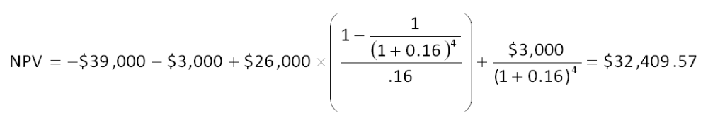

AACSB: Analytic
Bloom's: Application
Difficulty: Basic
Learning Objective: 10-1
Section: 10.3
Topic: Net present value
70. Jasper Metals is considering installing a new molding machine which is expected to produce operating cash flows of $73,000 a year for 7 years. At the beginning of the project, inventory will decrease by $16,000, accounts receivables will increase by $21,000, and accounts payable will increase by $15,000. All net working capital will be recovered at the end of the project. The initial cost of the molding machine is $249,000. The equipment will be depreciated straight-line to a zero book value over the life of the project. The equipment will be salvaged at the end of the project creating a $48,000 aftertax cash flow. At the end of the project, net working capital will return to its normal level. What is the net present value of this project given a required return of 14.5 percent?
A. $77,211.20
B. $79,418.80
C. $82,336.01
D. $84,049.74
E. $87,925.54
CF₀ = -$249,000 + $16,000 - $21,000 + $15,000 = -$239,000
C0₇ = $73,000 + $48,000 - $16,000 + $21,000 - $15,000 = $111,000
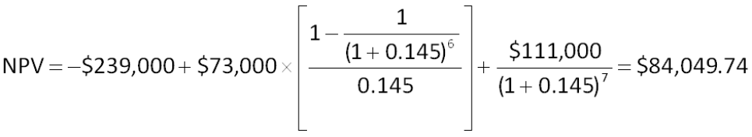

AACSB: Analytic
Bloom's: Analysis
Difficulty: Basic
Learning Objective: 10-1
Section: 10.3
Topic: Net present value
71. A project will produce an operating cash flow of $14,600 a year for 8 years. The initial fixed asset investment in the project will be $48,900. The net aftertax salvage value is estimated at $11,000 and will be received during the last year of the project's life. What is the net present value of the project if the required rate of return is 12 percent?
A. $23,627.54
B. $28,070.26
C. $34,627.54
D. $39,070.26
E. $41,040.83
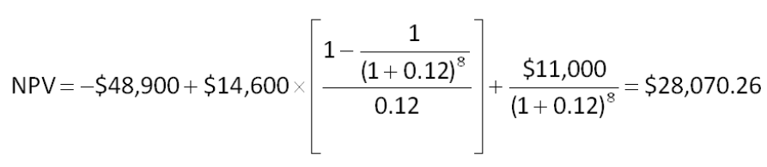

AACSB: Analytic
Bloom's: Analysis
Difficulty: Basic
Learning Objective: 10-1
Section: 10.3
Topic: Net present value
72. Kwik ‘n Hot Dogs is considering the installation of a new computerized pressure cooker that will cut annual operating costs by $23,000. The system will cost $39,900 to purchase and install. This system is expected to have a 4-year life and will be depreciated to zero using straight-line depreciation. What is the amount of the earnings before interest and taxes for this project?
A. $10,525
B. $13,025
C. $15,525
D. $16,900
E. $19,400
Earnings before interest and taxes = $23,000 - ($39,900/4) = $13,025

AACSB: Analytic
Bloom's: Application
Difficulty: Basic
Learning Objective: 10-1
Section: 10.6
Topic: Cost-cutting EBIT
73. Colors and More is considering replacing the equipment it uses to produce crayons. The equipment would cost $1.37 million, have a 12-year life, and lower manufacturing costs by an estimated $304,000 a year. The equipment will be depreciated using straight-line depreciation to a book value of zero. The required rate of return is 15 percent and the tax rate is 35 percent. What is the net income from this proposed project?
A. $18,508.75
B. $40,211.24
C. $66,441.67
D. $123,391.67
E. $136,709.48
Net income = [$304,000 - ($1,370,000/12)]  [1 - 0.35] = $123,391.67

AACSB: Analytic
Bloom's: Application
Difficulty: Intermediate
Learning Objective: 10-1
Section: 10.6
Topic: Cost-Cutting net income
74. Gateway Communications is considering a project with an initial fixed asset cost of $2.46 million which will be depreciated straight-line to a zero book value over the 10-year life of the project. At the end of the project the equipment will be sold for an estimated $300,000. The project will not directly produce any sales but will reduce operating costs by $725,000 a year. The tax rate is 35 percent. The project will require $45,000 of inventory which will be recouped when the project ends. Should this project be implemented if the firm requires a 14 percent rate of return? Why or why not?
A. No; The NPV is -$172,937.49.
B. No; The NPV is -$87,820.48.
C. Yes; The NPV is $251,860.34
D. Yes; The NPV is $387,516.67
E. Yes; The NPV is $466,940.57
Initial cash flow = -$2,460,000 - $45,000 = -$2,505,000
OCF = $725,000(1 - 0.35) + ($2,460,000/10)(0.35) = $557,350
Final cash flow = $45,000 + $300,000 (1 - 0.35) = $240,000
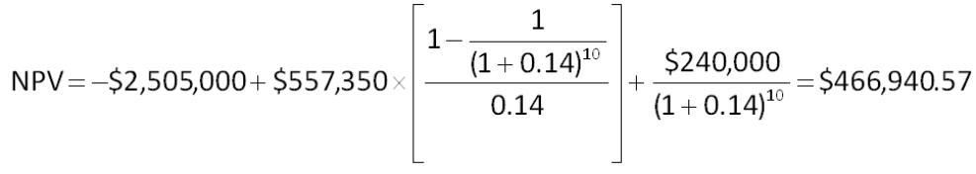

AACSB: Analytic
Bloom's: Analysis
Difficulty: Intermediate
Learning Objective: 10-2
Section: 10.3 and 10.6
Topic: Cost-cutting NPV
75. You are working on a bid to build two city parks a year for the next three years. This project requires the purchase of $180,000 of equipment that will be depreciated using straight-line depreciation to a zero book value over the 3-year project life. The equipment can be sold at the end of the project for $34,000. You will also need $20,000 in net working capital for the duration of the project. The fixed costs will be $16,000 a year and the variable costs will be $168,000 per park. Your required rate of return is 15 percent and your tax rate is 34 percent. What is the minimal amount you should bid per park? (Round your answer to the nearest $100)
A. $72,500
B. $128,600
C. $154,300
D. $189,100
E. $217,600
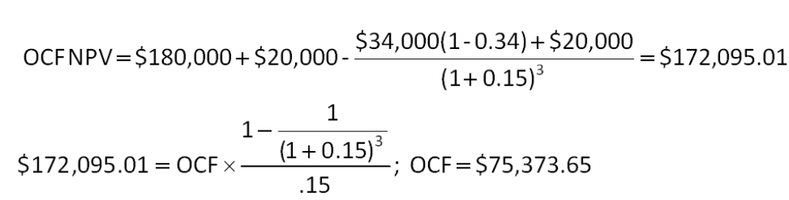
NI = $75,373.65 - ($180,000/3) = $15,373.65
EBT = $15,373.65/(1 - 0.34) = $23,293.41
Sales = $23,293.41 + ($180,000/3) + $16,000 + ($168,000  2) = $435,293.41
Bid per park = $435,293.41/2 = $217,646.71
When rounded to the nearest $100, the bid price is $217,600.

AACSB: Analytic
Bloom's: Analysis
Difficulty: Intermediate
Learning Objective: 10-3
Section: 10.6
Topic: Bid price
76. You are working on a bid to build two apartment buildings a year for the next 5 years for a local college. This project requires the purchase of $750,000 of equipment that will be depreciated using straight-line depreciation to a zero book value over the project's life. The equipment can be sold at the end of the project for $325,000. You will also need $140,000 in net working capital over the life of the project. The fixed costs will be $628,000 a year and the variable costs will be $1,298,000 per building. Your required rate of return is 14.5 percent for this project and your tax rate is 35 percent. What is the minimal amount, rounded to the nearest $100, you should bid per building?
A. $1,423,700
B. $1,489,500
C. $1,733,000
D. $2,780,600
E. $3,465,900
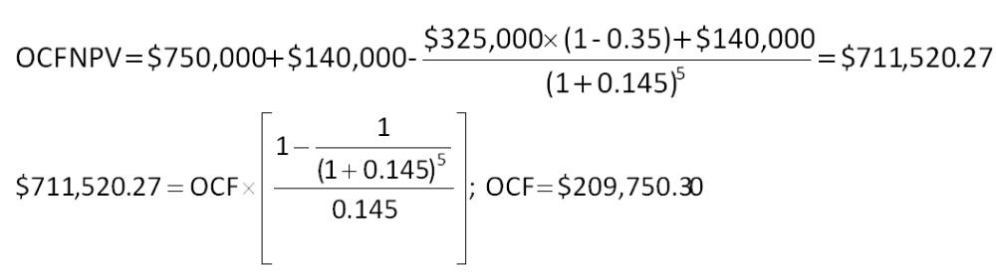
NI = $209,750.30 - ($750,000/5) = $59,750.30
EBT = $59,750.30/(1 - 0.35) = $91,923.54
Sales = $91,923.54 + ($750,000/5) + $628,000 + ($1,298,000  2) = $3,465,923.54
Bid per building = $3,465,923.54/2 = $1,732,961.77
When rounded to the nearest $100, the bid price is $1,733,000

AACSB: Analytic
Bloom's: Analysis
Difficulty: Intermediate
Learning Objective: 10-3
Section: 10.6
Topic: Bid price
77. Automated Manufacturers uses high-tech equipment to produce specialized aluminum products for its customers. Each one of these machines costs $1,480,000 to purchase plus an additional $49,000 a year to operate. The machines have a 6-year life after which they are worthless. What is the equivalent annual cost of one these machines if the required return is 16 percent?
A. -$450,657
B. -$427,109
C. -$301,586
D. -$295,667
E. -$256,947
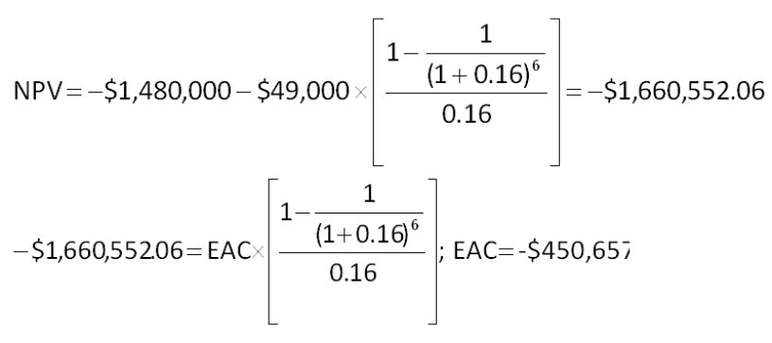

AACSB: Analytic
Bloom's: Analysis
Difficulty: Intermediate
Learning Objective: 10-4
Section: 10.6
Topic: Equivalent annual cost
78. Champion Bakers uses specialized ovens to bake its bread. One oven costs $689,000 and lasts about 4 years before it needs to be replaced. The annual operating cost per over is $41,000. What is the equivalent annual cost of an oven if the required rate of return is 13 percent?
A. -$272,638
B. -$248,313
C. -$232,407
D. -$200,561
E. $196,210
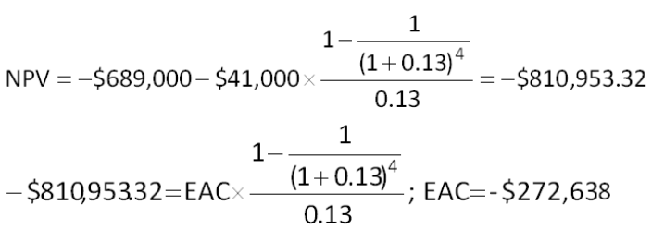

AACSB: Analytic
Bloom's: Analysis
Difficulty: Intermediate
Learning Objective: 10-4
Section: 10.6
Topic: Equivalent annual cost
79. Precision Tool is analyzing two machines to determine which one it should purchase. The company requires a 15 percent rate of return and uses straight-line depreciation to a zero book value over the life of its equipment. Machine A has a cost of $892,000, annual operating costs of $26,300, and a 4-year life. Machine B costs $1,127,000, has annual operating costs of $19,500, and has a 5-year life. Whichever machine is purchased will be replaced at the end of its useful life. Precision Tool should purchase Machine _____ because it lowers the firm's annual cost by approximately _______ as compared to the other machine.
A. A; $16,965.
B. A; $17,404
C. B; $16,965
D. B; $17,404
E. B; $17,521
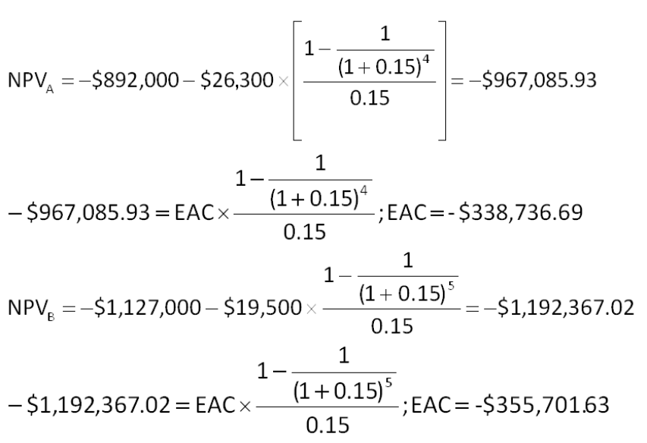
Difference in costs = -$338,736.69 - (-$355,701.63) = $16,964.94
Machine A lowers the firm's annual costs by about $16,965.

AACSB: Analytic
Bloom's: Analysis
Difficulty: Intermediate
Learning Objective: 10-4
Section: 10.6
Topic: Equivalent annual cost
80. The Buck Store is considering a project that will require additional inventory of $216,000 and will increase accounts payable by $181,000. Accounts receivable are currently $525,000 and are expected to increase by 9 percent if this project is accepted. What is the project's initial cash flow for net working capital?
A. -$82,250
B. -$12,250
C. $12,250
D. $36,250
E. $44,250
NWC requirement = -$216,000 + $181,000 - ($525,000  0.09) = - $82,250

AACSB: Analytic
Bloom's: Application
Difficulty: Basic
Learning Objective: 10-1
Section: 10.4
Topic: Net working capital
81. The Card Shoppe needs to maintain 23 percent of its sales in net working capital. Currently, the shoppe is considering a 6-year project that will increase sales from its current level of $387,000 to $421,000 the first year and to $465,000 a year for the following 5 years of the project. What amount should be included in the project analysis for net working capital in year 6 of the project?
A. -$17,940
B. -$2,990
C. $0
D. $2,990
E. $17,940
NWC recovery = ($465,000 - $387,000)  0.23 = $17,940

AACSB: Analytic
Bloom's: Application
Difficulty: Basic
Learning Objective: 10-1
Section: 10.4
Topic: Net working capital
82. Home Furnishings Express is expanding its product offerings to reach a wider range of customers. The expansion project includes increasing the floor inventory by $430,000 and increasing its debt to suppliers by 70 percent of that amount. The company will also spend $450,000 for a building contractor to expand the size of its showroom. As part of the expansion plan, the company will be offering credit to its customers and thus expects accounts receivable to rise by $90,000. For the project analysis, what amount should be used as the initial cash flow for net working capital?
A. -$39,000
B. -$70,000
C. -$156,000
D. -$219,000
E. -$391,000
NWC requirement = -$430,000 + (0.70  $430,000) - $90,000 = -$219,000

AACSB: Analytic
Bloom's: Application
Difficulty: Basic
Learning Objective: 10-1
Section: 10.4
Topic: Net working capital
83. Hollister & Hollister is considering a new project. The project will require $522,000 for new fixed assets, $218,000 for additional inventory, and $39,000 for additional accounts receivable. Short-term debt is expected to increase by $165,000. The project has a 6-year life. The fixed assets will be depreciated straight-line to a zero book value over the life of the project. At the end of the project, the fixed assets can be sold for 20 percent of their original cost. The net working capital returns to its original level at the end of the project. The project is expected to generate annual sales of $875,000 with costs of $640,000. The tax rate is 34 percent and the required rate of return is 14 percent. What is the project's cash flow at time zero?
A. -$536,000
B. -$614,000
C. -$720,000
D. -$779,000
E. -$944,000
Initial cash flow = -$522,000 - $218,000 - $39,000 + $165,000 = -$614,000

AACSB: Analytic
Bloom's: Application
Difficulty: Basic
Learning Objective: 10-1
Section: 10.4
Topic: Initial cash flow
84. Hollister & Hollister is considering a new project. The project will require $522,000 for new fixed assets, $218,000 for additional inventory, and $39,000 for additional accounts receivable. Short-term debt is expected to increase by $165,000. The project has a 6-year life. The fixed assets will be depreciated straight-line to a zero book value over the life of the project. At the end of the project, the fixed assets can be sold for 20 percent of their original cost. The net working capital returns to its original level at the end of the project. The project is expected to generate annual sales of $875,000 and costs of $640,000. The tax rate is 34 percent and the required rate of return is 14 percent. What is the amount of the earnings before interest and taxes for the first year of this project?
A. $97,680
B. $130,000
C. $148,000
D. $217,320
E. $235,000
EBIT = $875,000 - $640,000 - ($522,000/6) = $148,000

AACSB: Analytic
Bloom's: Application
Difficulty: Basic
Learning Objective: 10-1
Section: 10.3
Topic: Project earnings
85. Hollister & Hollister is considering a new project. The project will require $522,000 for new fixed assets, $218,000 for additional inventory, and $39,000 for additional accounts receivable. Short-term debt is expected to increase by $165,000. The project has a 6-year life. The fixed assets will be depreciated straight-line to a zero book value over the life of the project. At the end of the project, the fixed assets can be sold for 20 percent of their original cost. The net working capital returns to its original level at the end of the project. The project is expected to generate annual sales of $875,000 and costs of $640,000. The tax rate is 34 percent and the required rate of return is 14 percent. What is the amount of the aftertax cash flow from the sale of the fixed assets at the end of this project?
A. $35,496
B. $68,904
C. $104,400
D. $287,615
E. $344,520
Aftertax salvage value = $522,000  0.20  (1 - 0.34) = $68,904

AACSB: Analytic
Bloom's: Application
Difficulty: Basic
Learning Objective: 10-1
Section: 10.4
Topic: Aftertax salvage
86. Hollister & Hollister is considering a new project. The project will require $522,000 for new fixed assets, $218,000 for additional inventory, and $39,000 for additional accounts receivable. Short-term debt is expected to increase by $165,000. The project has a 6-year life. The fixed assets will be depreciated straight-line to a zero book value over the life of the project. At the end of the project, the fixed assets can be sold for 20 percent of their original cost. The net working capital returns to its original level at the end of the project. The project is expected to generate annual sales of $875,000 and costs of $640,000. The tax rate is 34 percent and the required rate of return is 14 percent. What is the cash flow recovery from net working capital at the end of this project?
A. $14,000
B. $75,000
C. $92,000
D. $344,000
E. $422,000
Net working capital recovery = $218,000 + $39,000 - $165,000 = $92,000

AACSB: Analytic
Bloom's: Application
Difficulty: Basic
Learning Objective: 10-1
Section: 10.4
Topic: Net working capital recovery
87. Keyser Mining is considering a project that will require the purchase of $980,000 in new equipment. The equipment will be depreciated straight-line to a zero book value over the 7-year life of the project. The equipment can be scraped at the end of the project for 5 percent of its original cost. Annual sales from this project are estimated at $420,000. Net working capital equal to 20 percent of sales will be required to support the project. All of the net working capital will be recouped. The required return is 16 percent and the tax rate is 35 percent. What is the value of the depreciation tax shield in year 4 of the project?
A. $49,000
B. $52,200
C. $68,600
D. $71,400
E. $76,500
Depreciation tax shield = $980,000/7  0.35 = $49,000

AACSB: Analytic
Bloom's: Application
Difficulty: Basic
Learning Objective: 10-1
Section: 10.4
Topic: Depreciation tax shield
88. Keyser Mining is considering a project that will require the purchase of $980,000 in new equipment. The equipment will be depreciated straight-line to a zero book value over the 7-year life of the project. The equipment can be scraped at the end of the project for 5 percent of its original cost. Annual sales from this project are estimated at $420,000. Net working capital equal to 20 percent of sales will be required to support the project. All of the net working capital will be recouped. The required return is 16 percent and the tax rate is 35 percent. What is the amount of the aftertax salvage value of the equipment?
A. $17,150
B. $31,850
C. $118,800
D. $237,600
E. $343,000
Aftertax salvage value = $980,000  0.05  (1 - 0.35) = $31,850

AACSB: Analytic
Bloom's: Application
Difficulty: Basic
Learning Objective: 10-1
Section: 10.4
Topic: Aftertax salvage
89. Keyser Mining is considering a project that will require the purchase of $980,000 in new equipment. The equipment will be depreciated straight-line to a zero book value over the 7-year life of the project. The equipment can be scraped at the end of the project for 5 percent of its original cost. Annual sales from this project are estimated at $420,000. Net working capital equal to 20 percent of sales will be required to support the project. All of the net working capital will be recouped. The required return is 16 percent and the tax rate is 35 percent. What is the recovery amount attributable to net working capital at the end of the project?
A. $21,000
B. $54,600
C. $84,000
D. $178,000
E. $196,000
NWC recapture = $420,000  0.20 = $84,000

AACSB: Analytic
Bloom's: Application
Difficulty: Basic
Learning Objective: 10-1
Section: 10.4
Topic: Net working capital recovery

Essay Questions
90. In a single sentence, explain how you can determine which cash flows should be included in the analysis of a project.
Any changes in cash flows that will result from accepting a new project should be included in the analysis of that project.
Feedback: Refer to section 10.1

AACSB: Reflective thinking
Bloom's: Comprehension
Difficulty: Basic
Learning Objective: 10-1
Section: 10.1
Topic: Relevant cash flows
91. What is the formula for the tax-shield approach to OCF? Explain the two key points the formula illustrates.
OCF = (Sales - Costs)  (1 - T) + Depreciation  T
The formula illustrates that cash income and expenses affect OCF on an aftertax basis. The formula also illustrates that even though depreciation is a non-cash expense it does affect OCF because of the tax savings realized from the depreciation expense.
Feedback: Refer to section 10.5

AACSB: Reflective thinking
Bloom's: Comprehension
Difficulty: Basic
Learning Objective: 10-1
Section: 10.5
Topic: Tax-shield OCF
92. What is the primary purpose of computing the equivalent annual costs when comparing two machines? What is the assumption that is being made about each machine?
The primary purpose is to compute the annual cost of each machine on a comparable basis so that the least expensive machine can be identified given that the machines generally have differing lives and costs. The assumption is that whichever machine is acquired, it will be replaced at the end of its useful life.
Feedback: Refer to section 10.6

AACSB: Reflective thinking
Bloom's: Comprehension
Difficulty: Basic
Learning Objective: 10-4
Section: 10.6
Topic: Equivalent annual cost
93. Assume a firm sets its bid price for a project at the minimum level as computed using the discounted cash flow method. Given this, what do you know about the net present value and the internal rate of return on the project as bid?
The discounted cash flow approach to setting a bid price assumes the net present value of the project will be zero which means the internal rate of return must equal the required rate.
Feedback: Refer to section 10.6

AACSB: Reflective thinking
Bloom's: Analysis
Difficulty: Intermediate
Learning Objective: 10-3
Section: 10.6
Topic: Bid price and NPV
94. Can the initial cash flow at time zero for a project ever be a positive value? If yes, give an example. If no, explain why not.
The initial cash flow can be a positive value. For example, if a project reduced net working capital by an amount that exceeded the initial cost for fixed assets, the initial cash flow would be a positive amount.
Feedback: Refer to section 10.2

AACSB: Reflective thinking
Bloom's: Analysis
Difficulty: Basic
Learning Objective: 10-1
Section: 10.2
Topic: Project cash flows
95. How can two firms arrive at two different bid prices when bidding for the same job and given the same bid specifications?
Each bidding firm usually arrives at a different calculated bid price because they use different assumptions in the evaluation process, such as the estimated time to complete the project, the material costs, and the estimated labor costs. In addition, firms often times have differing required rates of return and tax rates.
Feedback: Refer to section 10.6

AACSB: Reflective thinking
Bloom's: Analysis
Difficulty: Basic
Learning Objective: 10-3
Section: 10.6
Topic: Bid price

Multiple Choice Questions
96. Winnebagel Corp. currently sells 28,200 motor homes per year at $42,300 each, and 11,280 luxury motor coaches per year at $79,900 each. The company wants to introduce a new portable camper to fill out its product line. It hopes to sell 19,740 of these campers per year at $11,280 each. An independent consultant has determined that if Winnebagel introduces the new campers, it should boost the sales of its existing motor homes by 4,700 units per year, and reduce the sales of its motor coaches by 1,222 units per year. What is the amount that should be used as the annual sales figure when evaluating this project?
A. $297,613,400
B. $301,002,300
C. $314,141,800
D. $323,839,400
E. $327,289,500
Sales = (19,740  $11,280) + (4,700  $42,300) + (-1,222  $79,900) = $323,839,400

AACSB: Analytic
Bloom's: Analysis
Difficulty: Basic
EOC #: 10-2
Learning Objective: 10-1
Section: 10.1
Topic: Relevant cash flows
97. Consider the following income statement:
What is the amount of the depreciation tax shield?
A. $23,607
B. $24,192
C. $24,598
D. $26,211
E. $26,919
Depreciation tax shield = $75,600  .32 = $24,192

AACSB: Analytic
Bloom's: Application
Difficulty: Basic
EOC #: 10-4
Learning Objective: 10-1
Section: 10.5
Topic: Depreciation tax shield
98. Consider an asset that costs $176,000 and is depreciated straight-line to zero over its 11-year tax life. The asset is to be used in a 7-year project; at the end of the project, the asset can be sold for $22,000. The relevant tax rate is 30 percent. What is the aftertax cash flow from the sale of this asset?
A. $31,800
B. $32,600
C. $33,300
D. $34,100
E. $34,600
Book value at end of year 7 = $176,000  4/11 = $64,000
Aftertax salvage value = $22,000 + [($64,000 - $22,000)  .30] = $34,600

AACSB: Analytic
Bloom's: Application
Difficulty: Basic
EOC #: 10-7
Learning Objective: 10-1
Section: 10.4
Topic: Salvage value
99. Phone Home, Inc. is considering a new 6-year expansion project that requires an initial fixed asset investment of $5.994 million. The fixed asset will be depreciated straight-line to zero over its 6-year tax life, after which time it will be worthless. The project is estimated to generate $5,328,000 in annual sales, with costs of $2,131,200. The tax rate is 31 percent. What is the operating cash flow for this project?
A. $1,894,318
B. $2,211,407
C. $2,515,482
D. $2,663,021
E. $2,848,315
OCF = (5,328,000 - $2,131,200)(1 - 0.31) + ($5,994,000/6)(0.31) = $2,515,482

AACSB: Analytic
Bloom's: Application
Difficulty: Basic
EOC #: 10-9
Learning Objective: 10-1
Section: 10.3
Topic: Operating cash flow
100. Phone Home, Inc. is considering a new 5-year expansion project that requires an initial fixed asset investment of $2.484 million. The fixed asset will be depreciated straight-line to zero over its 5-year tax life, after which time it will be worthless. The project is estimated to generate $2,208,000 in annual sales, with costs of $883,200. The tax rate is 32 percent and the required return on the project is 11 percent. What is the net present value for this project?
A. $1,432,155
B. $1,433,059
C. $1,434,098
D. $1,434,217
E. $1,435,008
OCF = ($2,208,000 - $883,200)(1 - 0.32) + ($2,484,000/5)(0.32) = $1,059,840
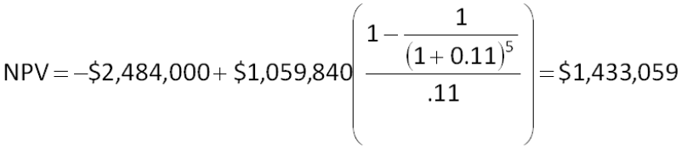

AACSB: Analytic
Bloom's: Application
Difficulty: Basic
EOC #: 10-10
Learning Objective: 10-1
Section: 10.3
Topic: Net present value
101. Phone Home, Inc. is considering a new 4-year expansion project that requires an initial fixed asset investment of $3 million. The fixed asset will be depreciated straight-line to zero over its 4-year tax life, after which time it will have a market value of $231,000. The project requires an initial investment in net working capital of $330,000, all of which will be recovered at the end of the project. The project is estimated to generate $2,640,000 in annual sales, with costs of $1,056,000. The tax rate is 31 percent and the required return for the project is 15 percent. What is the net present value for this project?
A. $714,056
B. $733,970
C. $741,335
D. $742,208
E. $744,595
OCF = ($2,640,000 - $1,056,000)(1 - 0.31) + ($3,000,000/4)(0.31) = $1,325,460
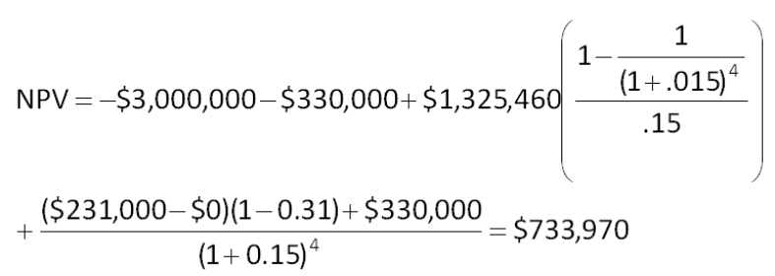

AACSB: Analytic
Bloom's: Application
Difficulty: Basic
EOC #: 10-11
Learning Objective: 10-1
Section: 10.3
Topic: Net present value
102. Dog Up! Franks is looking at a new sausage system with an installed cost of $397,800. This cost will be depreciated straight-line to zero over the project's 7-year life, at the end of which the sausage system can be scrapped for $61,200. The sausage system will save the firm $122,400 per year in pretax operating costs, and the system requires an initial investment in net working capital of $28,560. All of the net working capital will be recovered at the end of the project. The tax rate is 33 percent and the discount rate is 9 percent. What is the net present value of this project?
A. -$41,311
B. -$7,820
C. $81,507
D. $98,441
E. $118,821
OCF = $122,400(1 - 0.33) + ($397,800/7)(0.33) = $100,761.43
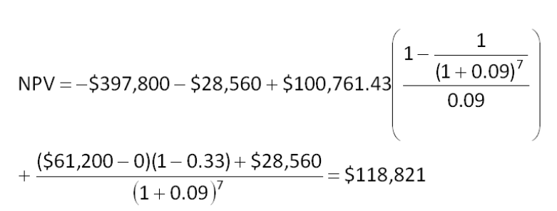

AACSB: Analytic
Bloom's: Application
Difficulty: Basic
EOC #: 10-13
Learning Objective: 10-1
Section: 10.3
Topic: Net present value
103. Your firm is contemplating the purchase of a new $1,628,000 computer-based order entry system. The system will be depreciated straight-line to zero over its 5-year life. It will be worth $158,400 at the end of that time. You will save $633,600 before taxes per year in order processing costs and you will be able to reduce working capital by $115,764 (this is a one-time reduction). The net working capital will return to its original level when the project ends. The tax rate is 35 percent. What is the internal rate of return for this project?
A. 11.78 percent
B. 13.49 percent
C. 18.21 percent
D. 21.65 percent
E. 23.58 percent
OCF = $663,600(1 - 0.35) + ($1,628,000/5)(0.35) = $525,800
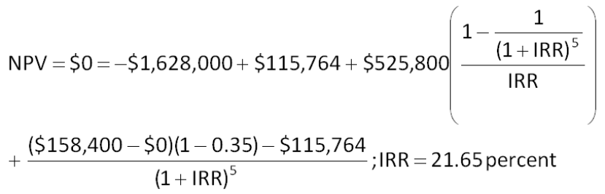

AACSB: Analytic
Bloom's: Application
Difficulty: Basic
EOC #: 10-14
Learning Objective: 10-1
Section: 10.3
Topic: Internal rate of return
104. A 4-year project has an initial asset investment of $306,600, and initial net working capital investment of $29,200, and an annual operating cash flow of -$46,720. The fixed asset is fully depreciated over the life of the project and has no salvage value. The net working capital will be recovered when the project ends. The required return is 15 percent. What is the project's equivalent annual cost, or EAC?
A. -$158,491
B. -$152,309
C. -$147,884
D. -$145,509
E. -$142,212
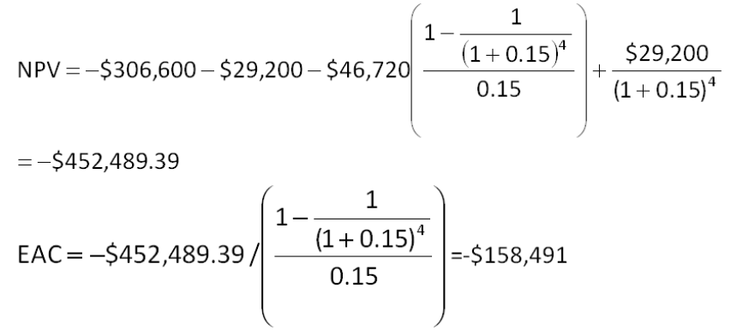

AACSB: Analytic
Bloom's: Application
Difficulty: Basic
EOC #: 10-16
Learning Objective: 10-4
Section: 10.6
Topic: Equivalent annual cost
105. Heer Enterprises needs someone to supply it with 225,000 cartons of machine screws per year to support its manufacturing needs over the next 7 years, and you've decided to bid on the contract. It will cost you $1,170,000 to install the equipment necessary to start production; you'll depreciate this cost straight-line to zero over the project's life. You estimate that in 7 years, this equipment can be salvaged for $75,000. Your fixed production costs will be $360,000 per year, and your variable production costs should be $12.75 per carton. You also need an initial investment in net working capital of $112,500, all of which will be recovered when the project ends. Your tax rate is 32 percent and you require a 13 percent return on your investment. What bid price per carton should you submit?
A. $17.04
B. $16.56
C. $15.79
D. $15.03
E. $14.81
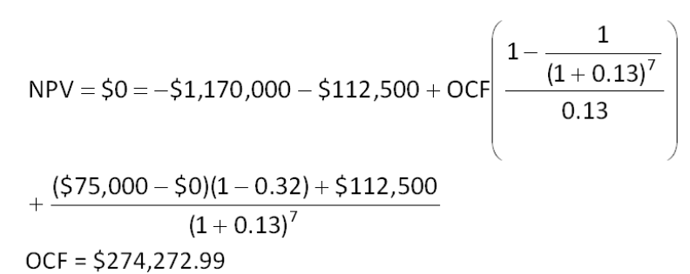
$274,272.99 = [(P - $12.75)(225,000) - $360,000][1 - 0.32) + ($1,170,000/7)(0.32)
P = $15.79

AACSB: Analytic
Bloom's: Analysis
Difficulty: Basic
EOC #: 10-18
Learning Objective: 10-3
Section: 10.6
Topic: Bid price
106. Chapman Machine Shop is considering a 4-year project to improve its production efficiency. Buying a new machine press for $576,000 is estimated to result in $192,000 in annual pretax cost savings. The press falls in the MACRS 5-year class, and it will have a salvage value at the end of the project of $84,000. The press also requires an initial investment in spare parts inventory of $24,000, along with an additional $3,600 in inventory for each succeeding year of the project. The inventory will return to its original level when the project ends. The shop's tax rate is 35 percent and its discount rate is 11 percent. Should the firm buy and install the machine press? Why or why not?
A. no; The net present value is -$7,489.
B. no; The net present value is -$667.
C. yes; The net present value is $211.
D. yes; The net present value is $4,319.
E. yes; The net present value is $8,364.
Deprec₁ = $576,000  0.20 = $115,200
Deprec₂ = $576,000  0.32 = $184,320
Deprec₃ = $576,000  0.1920 = $110,592
Deprec₄ = $576,000  0.1152 = $66,355.20
Book value₄ = $576,000 - $115,200 - $184,320 - $110,592 - $66,355.20 = $99,532.80
Aftertax salvage value = $84,000 + ($99,532.80 - $84,000)(0.35) = $89,436.48
OCF₁ = $192,000(1 - 0.35) + $115,200(0.35) = $165,120
OCF₂ = $192,000(1 - 0.35) + $184,320(0.35) = $189,312
OCF₃ = $192,000(1 - 0.35) + $110,592(0.35) = $163,507.20
OCF₄ = $192,000(1 - 0.35) + $66,355.20(0.35) = $148,024.32
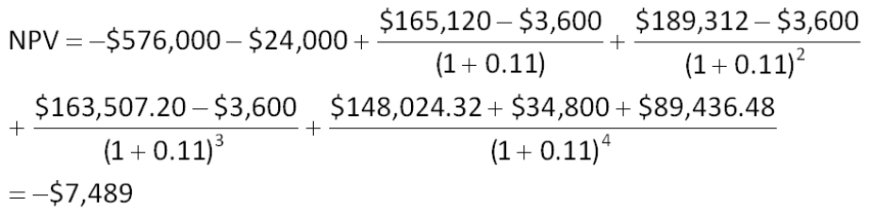
The machine should not be purchased because the net present value is negative.

AACSB: Analytic
Bloom's: Analysis
Difficulty: Intermediate
EOC #: 10-19
Learning Objective: 10-2
Section: 10.6
Topic: Costs-cutting proposal
107. Eads Industrial Systems Company (EISC) is trying to decide between two different conveyor belt systems. System A costs $427,000, has a 6-year life, and requires $112,000 in pretax annual operating costs. System B costs $517,000, has an 8-year life, and requires $79,000 in pretax annual operating costs. Both systems are to be depreciated straight-line to zero over their lives and will have a zero salvage value. Whichever system is chosen, it will not be replaced when it wears out. The tax rate is 33 percent and the discount rate is 24 percent. Which system should the firm choose and why?
A. A; The net present value is $211,516.
B. A; The net present value is -$582,720.
C. A; The net present value is -$314,216.
D. B; The net present value is $308,222.
E. B: The net present value is -$625,123.
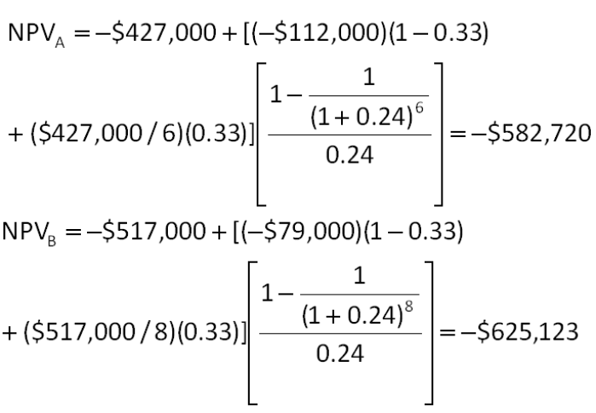
System A should be chosen because it has the more positive (smaller negative) net present value.

AACSB: Analytic
Bloom's: Analysis
Difficulty: Intermediate
EOC #: 10-20
Learning Objective: 10-1
Section: 10.3
Topic: Mutually exclusive projects
108. Consider a project to supply 60,800,000 postage stamps to the U.S. Postal Service for the next 5 years. You have an idle parcel of land available that cost $760,000 five years ago; if the land were sold today, it would net you $912,000, aftertax. The land can be sold for $1,500,000 after taxes in 5 years. You will need to install $2,356,000 in new manufacturing plant and equipment to actually produce the stamps; this plant and equipment will be depreciated straight-line to zero over the project's 5-year life. The equipment can be sold for $456,000 at the end of the project. You will also need $469,000 in initial net working capital for the project, and an additional investment of $38,000 in every year thereafter. All net working capital will be recovered when the project ends. Your production costs are 0.38 cents per stamp, and you have fixed costs of $608,000 per year. Your tax rate is 31 percent and your required return on this project is 11 percent. What bid price per stamp should you submit?
A. $0.018
B. $0.020
C. $0.023
D. $0.026
E. $0.029
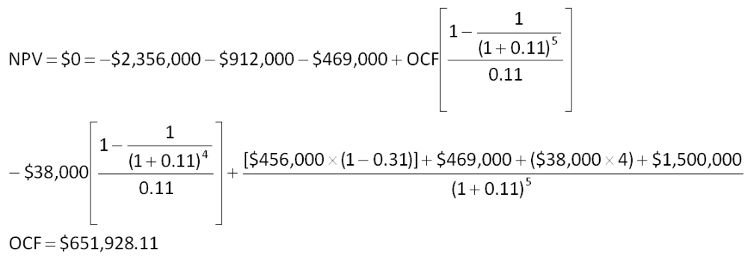
$651,928.11 = [(P-$0.0038)(60,800,000) - $608,000][1 - 0.31] + ($2,356,000/5)(0.31)
P = $0.026

AACSB: Analytic
Bloom's: Application
Difficulty: Intermediate
EOC #: 10-22
Learning Objective: 10-3
Section: 10.6
Topic: Bid price

